Faculty of Science and Technology
CST2590
Internet of Things
Enhanced Lab Book
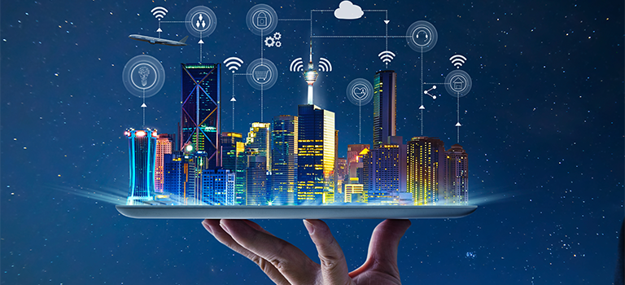
Submission: Week 12

Student Name | Jude Okoduwa
Student ID | M01113955
Lecturer Name | Dr Kamran Ali

How to Use This Lab Book
A structured journey from IoT concepts to connected, secure and integrated systems
Purpose
This lab book is designed to help you move from understanding basic IoT concepts to building, connecting, testing and evaluating complete IoT systems. Evidence should include your own circuit screenshots or lab photographs, code, results and reflection.

13-week learning journey (Week 0 to Week 12)
Week | Session (week of) | Focus | Main evidence
0 |  | Induction & orientation | Accounts set up, safety sign-off, IoT mind-map
1 |  | IoT foundations | Research, examples and applications
2 |  | Hardware | Microcontrollers, SBCs, sensors and actuators
3 |  | Arduino simulation | Outputs, RGB LEDs and switches
4 |  | Sensor simulation | Temperature, light and gas sensing
5 |  | Smart decisions | Ultrasonic sensing, alarms and displays
6 |  | Physical hardware | MKR WiFi 1010 build and sensor integration
7 |  | Cloud IoT | Remote monitoring and device control
8 |  | Connectivity | WiFi, MQTT and device-to-cloud communication
9 |  | Integrated systems | Smart plant, parking and room systems
10 |  | Investigation & research | Calibration, signal strength, response time, emerging topics
11 |  | Innovation project | Design and build your own IoT solution
12 |  | Evaluation | Demonstration, reflection and final submission (by 15 Dec)
Note: dates are shown as “week commencing” and assume one 3-hour lab each week from 20 September to 15 December. Dates can be adjusted if your timetable includes a reading week or a bank holiday.

Evidence expected for each practical activity
- Circuit/build evidence
- Commented code or flowchart
- Results or sensor readings
- Short explanation of code function
- Reflection on what worked and what you changed
- Completion of the challenge or extension where possible

Lab Safety and Good Practice
Before you start
Follow your lecturer's safety instructions and check all wiring before powering a circuit. Never connect components if you are unsure of voltage, current, polarity or pin configuration.

Hardware safety: Power off before changing wiring. Use suitable resistors with LEDs. Check sensor and actuator voltage requirements. Keep liquids away from electronic equipment.
Network and cloud safety: Do not place passwords, API keys or WiFi credentials in screenshots or public repositories. Use test accounts and approved services.
Data privacy: Do not collect personal or sensitive data unless the activity specifically requires it and you have been instructed how to handle it.
Academic practice: Your lab book should show your own understanding. You may discuss activities with classmates, but explanations, reflections and evidence should be your own.

Week 0 – Induction and Orientation
Getting set up before the hands-on work begins
Welcome to CST2590 Internet of Things. Week 0 is a short set-up and orientation session. Its goal is to make sure that, before Week 1, you have the accounts, tools and safety knowledge you need so that no lab time is later lost to admin. There is no marked hardware work this week – just set-up, a safety sign-off and a gentle research warm-up.
In this first session you will:
- Meet the teaching team and get an overview of the module, the weekly plan and how this lab book is assessed.
- Create the free accounts you will use all term (see the set-up checklist below).
- Complete the health, safety and good-practice sign-off before touching any hardware.
- Start your “IoT all around you” mind-map, which you will build on in Week 1.

Set-up checklist (tick when done)
☐ Autodesk Tinkercad account created (for circuit simulation).
☐ Arduino IoT Cloud account created (create.arduino.cc) and email verified.
☐ Arduino IDE installed, or Arduino Web Editor tested in your browser.
☐ Joined the CST2590 module area / online space and located this lab book.
☐ Located the MKR WiFi 1010 board pinout diagram and saved a copy.
☐ Read the Lab Safety and Good Practice page and understood it.

Health and safety sign-off
I confirm that I have read the Lab Safety and Good Practice guidance in this lab book, that I will power off circuits before rewiring, and that I will not share WiFi credentials, API keys or personal data in screenshots or public repositories.

Name: ____________Jude Okoduwa________________ Signature: ___JudeOkoduwa_________________________ Date: __28/09/2026____________

Week 0 mini-task: IoT all around you
This short warm-up needs no hardware. Answer briefly in your own words. Keep it – you will reuse and extend these ideas in Research-Based Activity 1.

1. List five everyday objects near you right now that are, or could easily become, “smart” (connected). For each, note what it might sense and what it might do.

Light Bulb:

Senses: Ambient light, occupancy (with a motion sensor), time of day.
Does: Dims or brightens automatically, switches on when you enter a room, follow schedules
_______________________________________________________________________________________________________________________________________
Doorbell or Door Lock:

Senses: motion a person at the door, whether the door is opened or locked.
Does: Streams videos, sends alert, unlocks for a trusted phone or code, logs entry times.
_______________________________________________________________________________________________________________________________________

Kettle or power socket:
Senses: power draw, water temperature (kettle) or whether an appliance is on or off (socket)
Does: starts boiling on a voice command or schedule, cuts power to things left on, tracks energy use. _____________________________________________________________________________________________________________________________________
Thermostat or radiator valve:
Senses: room temperature, humidity, whether anyone is home
Does: adjusts heating by room and schedule, pre-heats before you arrive, learns your patterns
_______________________________________________________________________________________________________________________________________
Smoke or carbon monoxide alarm:
Senses: smoke particles, CO levels, sometimes temperature
Does: alerts your phone when you're away, triggers lights, and can shut off connected heating

_______________________________________________________________________________________________________________________________________

2. Pick one of them. What single piece of information would it need to collect, and what decision or action could that information trigger?

Thermostat:
It collects information whether anyone is home (occupancy), detected through a motion sensor or the presence of a household phone on the Wi-Fi.
Decision it triggers: if the house has been empty for a set period, say 30 minutes, the thermostat lowers the heating to a minimum setting, such as 13°C, to save energy. When someone returns, or is detected approaching, it switches the heating back to the normal temperature, so the home is warm on arrival.
This one signal drives a useful decision on its own: you avoid heating an empty house, which cuts energy use and bills without any manual effort.

_______________________________________________________________________________________________________________________________________

_______________________________________________________________________________________________________________________________________
3. What is one benefit and one risk (privacy, security or reliability) of making that object connected?

Benefit: Remote control and automation. Being connected lets you adjust the heating from your phone, or have it respond to occupancy, so you save energy and avoid coming home to a cold house without having to remember to do anything.
Risk (privacy): The occupancy data it collects reveals when your home is empty. If the thermostat's cloud service is breached, or the account is poorly secured, that pattern of when you're in, out or away on holiday could be exposed or misused, for example by burglars or for profiling by third parties.
Using a strong unique password, enabling two-factor authentication, and keeping the device on a separate network from your main devices all reduce that exposure.
______________________________________________________________________________________________________________________________________
_______________________________________________________________________________________________________________________________________
4. How would your chosen object send its information somewhere useful – for example to your phone, another device or the cloud? Describe the path the data would take from sensing to action.
_______________________________________________________________________________________________________________________________________
Here is the path for the smart thermostat, from sensing to action:
- Sensing: The motion sensor and temperature sensor inside the thermostat take readings. A phone's presence on the home Wi-Fi can also count as an occupancy signal.
- Local processing: A small microcontroller in the thermostat checks the readings against its rules. For example: "no motion for 30 minutes, so the house is probably empty."
- Transmission: The thermostat sends the data over your home Wi-Fi (or Zigbee/Thread via a hub) to your router. Protocols like MQTT or HTTPS are commonly used, and the traffic should be encrypted.
- Cloud: The router forwards the data over the internet to the manufacturer's cloud server. The cloud stores the history, applies schedules or learning algorithms, and keeps your account and app in sync.
- Your phone: The cloud pushes a notification or updates the app, for example "Heating lowered, house empty." You can also send commands back the other way, such as "heat to 20°C now."
- Action: The command returns to the thermostat, which signals the boiler or radiator valves to turn heating down or up.
For reliability, a well-designed thermostat does the basic decision-making locally in step 2, so it keeps working on its schedule if the internet or cloud goes down. Systems like Home Assistant can also keep the whole path inside your home network, which removes the cloud from the privacy picture.

_____________________________________________________________________________________________________________________________________

5. Imagine hundreds of these connected objects around your home, campus or city. Describe one new possibility this could create, and one new problem that might appear when so many devices are connected.

_______________________________________________________________________________________________________________________________________
New possibility: coordinated, city-scale energy management. If hundreds of thousands of thermostats report occupancy and temperature, a utility could treat them as one flexible system. On a cold evening when demand peaks, they could each lower heating by a degree or two for 20 minutes, or pre-heat homes slightly earlier when renewable power is plentiful. No single home would notice much, but together they flatten demand spikes, cut costs and reduce the need for fossil-fuel backup plants.
New problem: a much larger and more dangerous attack surface. The same coordination that makes the system useful makes it a target. If an attacker compromises many devices through a shared flaw, such as a default password or a bad firmware update, they can control them all at once. A botnet of hijacked thermostats could be used for DDoS attacks, as happened with Mirai. A synchronised on/off switch across a city could also cause a sudden surge or drop in grid demand, destabilising supply. The weakness is scale: one vulnerability repeated across hundreds of thousands of devices becomes an infrastructure risk rather than a household one.
Mitigations include signed firmware updates, unique per-device credentials, network segmentation, and limiting how much any central controller can change at once.

_______________________________________________________________________________________________________________________________________

_______________________________________________________________________________________________________________________________________

_______________________________________________________________________________________________________________________________________

_______________________________________________________________________________________________________________________________________

_______________________________________________________________________________________________________________________________________
Bring your answers and mind-map to Week 1.

Research-Based Activity 1
IoT Foundations, Applications and Emerging Technologies

- Answer in your own words and use suitable examples.
- Where you use external information, record the source requested by your lecturer.
- Try to connect research answers to the practical work later in this lab book.

- How would you define the Internet of Things (IoT) in your own words, and can you describe five examples of IoT devices you encounter in everyday life?

Internet of things (IoT) can be defined as the idea of giving everyday physical objects, such as thermostats, watches, doorbells and like car parts, sensors and a network connection so they can collect data, share it with other devices or services over the internet. It can report what is happening around it, be controlled remotely, and work together with other devices without a person needing to step in each time.
_______________________________________________________________________________________________________________________________________

Doorbell Camera
Smoke Alarm
Light Bulb
Smart speaker
Smart watch/ Fitness Tracker

_______________________________________________________________________________________________________________________________________

_______________________________________________________________________________________________________________________________________

_______________________________________________________________________________________________________________________________________

- When we talk about “things” in IoT, what exactly do we mean? Identify both simple and complex things that can connect to a network.

Simple Things (Single purpose, few sensors, little processing power):
_______________________________________________________________________________________________________________________________________
Smart Bulbs and plugs: Just on/off or dimming, controlled remotely
Temperature or humidity sensors: send one reading at interval
Door/Window contact sensors: report open or closed.
Bluetooth trackers (Airtag): report location through nearby devices
Smart meters: transmit usage readings to the supplier.
_______________________________________________________________________________________________________________________________________

Complex Things (many sensors, real computing power, multiple functions):

Connected cars: hundreds of sensors, GPS, diagnostics, navigation, software updates and driver assistance.
Smart phone and smart watches: acts as a sensor, controller and gateways for other devices.
Smart TVs and speakers: run full operating systems, apps and voice recognition
Medical devices (insulin pumps, patient monitors): collects critical data and can act on it.
Whole systems: smart home, smart grids, traffic management and smart cities, which combines thousand of devices and the cloud.

_______________________________________________________________________________________________________________________________________
The difference between simple and complex things is mainly in how much a device senses, processes and decides. Simple devices usually just report data or follow a command, while complex ones analyses the data and act on it.
_______________________________________________________________________________________________________________________________________

_______________________________________________________________________________________________________________________________________

_______________________________________________________________________________________________________________________________________
3. What are the key components that make up an IoT system, and how do they work together to create a connected environment?

The key components of an IoT system are;

Devices and sensors/actuators: Sensors collect data and actuators act on the data collected.

Connectivity: How data travels. This includes Wi-Fi, Bluetooth, zigbee, thread, cellular (4G/5G, NB-IoT)
Using protocols such as MQTT or HTTPS.

Gateway or Edge Devices: This bridges local device to the internet. It translates between protocols, filter data and process data locally. This reduces delay and keeps basic functions working if internet drops.

Cloud or Data Platform: Receives, stores and processes the data, runs analytics and processes device updates.

User Interface and Application: Dashboard, mobile apps or voice assistants where people view data, set rules or send commands.

Running through all of these is security (authentication, encryption, firmware updates), which isn’t a separate layer so much as something every component needs.
_______________________________________________________________________________________________________________________________________

The components form a continuous loop: sense, transmit, process, decide, act, and report back.
Devices sense something in the environment, such as no motion in the house.
Connectivity carries that reading, usually to a gateway first (your router or hub).
The gateway passes it on, translating between protocols and sometimes handling simple decisions locally so things still work if the internet drops.
The cloud processes it, combining it with other data (schedules, weather, history) and applying rules or analytics to decide what should happen.
The decision flows back down the same path as a command, and an actuator acts, for example the thermostat lowering the heating.
The interface keeps you in the loop, showing what happened and letting you override it, which changes the rules for next time.
______________________________________________________________________________________________________________________________________

________________________________________________________________________
4. Think about your daily routine. In what five to ten ways could IoT make life easier, safer or more efficient?

- Waking up (easier): Smart lights and heating come on gradually before your alarm, and the alarm can adjust if your sleep tracker shows you slept badly or traffic is heavy.
- Getting ready (efficient): A smart thermostat and smart plugs mean the house is warm when you’re up and nothing stays on that shouldn’t. A smart mirror or app can show the weather and transport delays.
- Leaving home (safer): A smart lock and door sensors confirm everything is shut, and you can check or lock up from your phone if you forget. Cameras and alerts cover the empty house.
- Commuting (efficient): Live bus and train trackers, connected car diagnostics and traffic-aware navigation reduce delays and the chance of a breakdown.
- At work or study (efficient): Smart building systems adjust lighting and heating by room occupancy, and smart badges or access control manage who can enter.
- Health through the day (safer): A smartwatch tracks heart rate, activity and sleep, and can prompt you to move or alert you to unusual readings.
- While you’re out (safer): Smoke, CO and water-leak sensors alert your phone to problems at home immediately, before they become major damage.
- Chores and shopping (easier): A robot vacuum cleans on schedule, and a connected fridge or smart-speaker list helps you keep track of what you need to buy.
- Evening (efficient): Smart meters and energy monitors show where electricity is going, and appliances can run when tariffs are cheapest.
- Night (safer and easier): A single “goodnight” routine switches off lights, locks doors, lowers heating and arms sensors.
_____________________________________________________________________________________________________________________________________
_______________________________________________________________________________________________________________________________________

_______________________________________________________________________________________________________________________________________

5. What issues do organisations face when adopting IoT, and why are these challenges important?

Organisations typically face six main challenges when adopting IoT.
- Security: Every device is a potential entry point, and many ship with weak default passwords, no encryption or infrequent patches. Why it matters: one compromised sensor can give attackers a route into the wider corporate network, and in industrial or medical settings a breach can cause physical harm, not just data loss.
- Privacy and legal compliance: IoT collects large amounts of data, some of it personal (location, behaviour, health). Organisations must comply with laws such as UK GDPR and the Data Protection Act. Why it matters: breaches and misuse bring heavy fines, legal action and loss of customer trust.
- Interoperability: Devices from different vendors use different protocols, standards and platforms. Why it matters: poor integration leads to vendor lock-in, data silos and systems that can’t work together, which defeats the point of a connected environment.
- Scalability and data management: Thousands of devices generate huge volumes of data that must be stored, processed and made useful. Why it matters: without the right infrastructure, costs balloon and the data is never turned into decisions, so the investment delivers little value.
- Reliability and maintenance: Devices need power, connectivity, firmware updates and replacement over many years, often in remote locations. Why it matters: an outage or failed update can halt operations, and unmanaged or abandoned devices become long-term security liabilities.
- Cost and skills: Upfront hardware, integration and ongoing support costs are significant, and staff need expertise in networking, security and data analysis. Why it matters: without clear business goals and skilled people, projects stall or fail to show a return, and gaps in expertise tend to lead to security mistakes.

_______________________________________________________________________________________________________________________________________

_______________________________________________________________________________________________________________________________________

6. How is IoT transforming manufacturing? Give examples of smart factories or processes where IoT plays a key role.

IoT is shifting manufacturing from reacting to problems to predicting and optimising in real time. Machines, products and processes are fitted with sensors that stream data to analytics systems, so decisions are based on live information rather than periodic checks.
Key ways it’s changing things
- Predictive maintenance: Vibration, temperature and power sensors on machines detect early signs of wear, so repairs happen before a breakdown. This cut unplanned downtime, which is very costly on a production line.
- Quality control: Sensors and cameras check products as they’re made and flag defects immediately, rather than at the end of the line, which reduces waste and rework.
- Real-time tracking: RFID tags and connected tools track parts, work-in-progress and finished goods through the factory and supply chain, improving stock control and traceability.
- Digital twins: A live virtual model of a machine or whole factory, fed by sensor data, lets engineers test changes and spot bottlenecks without disrupting production.
- Energy and resource efficiency: Smart meters and sensors show which machines use the most power or materials, so waste can be reduced.
- Worker safety: Wearables and environmental sensors monitor hazards such as gas, heat or machinery proximity and trigger alerts.
- Flexible, automated production: Connected robots and machines can be reconfigured quickly to produce different product variants, supporting mass customisation.
Examples
- Siemens Electronics Works, Amberg (Germany): A well-known smart factory where products and machines communicate with each other, with a high degree of automation and very low defect rates. It is often used as a showcase of Industry 4.0.
- BMW Group: Uses digital twins to plan and simulate factory layouts and production lines virtually before changing the real plant.
- Bosch: Applies connected manufacturing across its own plants, using sensor data for predictive maintenance and tracking production performance.
- Rolls-Royce: Fits sensors to aircraft engines to monitor performance in flight and predict servicing needs, which shows how IoT extends beyond the factory into the product’s whole lifecycle.
__________________________________________________________________________________________________________________________________

_______________________________________________________________________________________________________________________________________

_______________________________________________________________________________________________________________________________________

7. How could IoT technologies be used to improve farming and food production?

IoT lets farmers manage land, crops and livestock using live data instead of routine or guesswork. This is often called precision agriculture.
Crops and soil
- Soil sensors measure moisture, temperature and nutrient levels, so irrigation and fertiliser go only where and when needed. This saves water and cuts input costs.
- Weather stations and forecasts feed automated decisions, such as delaying irrigation before rain or warning of frost.
- Drones and satellite imaging spot disease, pests or nutrient stress across large fields early, so treatment can target small areas instead of whole fields.
- Connected tractors and machinery use GPS to plant, spray and harvest with high accuracy, reducing overlap and waste.
Livestock
- Wearable tags or collars track location, temperature, activity and feeding patterns, flagging illness or calving early.
- Automated milking and feeding systems record yield and health data per animal and adjust feed accordingly.
- Virtual fencing and GPS tracking help manage grazing and locate stray animals.
Greenhouses and indoor farming
- Sensors control temperature, humidity, CO₂ and lighting automatically, and vertical farms use this to grow crops year-round with far less water.
Storage, supply chain and food safety
- Temperature and humidity sensors in silos, cold stores and delivery vehicles prevent spoilage and prove food has been kept safe.
- RFID, barcodes and sensor logs support traceability from farm to shelf, so contaminated batches can be identified and recalled quickly.
Overall benefits
- Higher yields with less water, fertiliser and pesticide.
- Lower costs and less environmental impact.
- Earlier warning of crop and animal health problems.
- Better food safety and less waste.
Challenges
- Poor rural connectivity, which is why long-range, low-power networks such as LoRaWAN and NB-IoT are common on farms.
- Upfront cost, which can be hard for small farms.
- Sensors that must survive weather, mud and battery limits.
- Data ownership and security, since farm data is commercially valuable.
___________________________________________________________________________________________________________________________________

_______________________________________________________________________________________________________________________________________

_______________________________________________________________________________________________________________________________________

_______________________________________________________________________________________________________________________________________

_______________________________________________________________________________________________________________________________________

_______________________________________________________________________________________________________________________________________

_______________________________________________________________________________________________________________________________________

_______________________________________________________________________________________________________________________________________

8. What effects do IoT devices have on patient care, hospital management and health monitoring?

IoT in healthcare is often called the Internet of Medical Things (IoMT). Its effects fall into three areas.
Patient care
- Remote patient monitoring: Wearables and home devices (glucose monitors, blood pressure cuffs, ECG patches, pulse oximeters) send readings to clinicians, so chronic conditions can be managed at home with fewer hospital visits.
- Earlier intervention: Continuous data can reveal deterioration before symptoms are obvious, and alerts prompt faster action.
- Smart medical devices: Connected insulin pumps, infusion pumps and inhalers can adjust or track doses, and record whether medication was actually taken.
- Better outcomes and independence: Elderly or vulnerable patients can stay at home longer with fall detection and emergency alerts.
Hospital management
- Asset tracking: RFID or Bluetooth tags locate wheelchairs, ventilators and monitors quickly, saving staff time and reducing equipment loss.
- Smart beds and patient flow: Sensors show bed occupancy, helping manage admissions, discharges and waiting times.
- Environmental control: Monitoring of temperature in vaccine fridges and blood storage, plus air quality and hygiene compliance (such as hand-wash tracking), supports safety and regulation.
- Maintenance and supplies: Devices report faults early, and stock levels can trigger automatic reordering.
- Staff efficiency: Less manual data entry and fewer routine check free clinicians for direct care.
Health monitoring (general population)
- Smartwatches and fitness trackers collect heart rate, sleep and activity data, supporting prevention and lifestyle changes, and some can detect irregular heart rhythms.
- Aggregated data helps researchers and public health bodies spot trends.
Risks and downsides
- Security: A compromised medical device or hospital network can endanger patients directly, not just expose data, as with ransomware that disrupts hospital systems.
- Privacy: Health data is highly sensitive and tightly regulated (UK GDPR treats it as special category data).
- Reliability: Dead batteries, connectivity loss or sensor errors can cause missed alerts or false alarms, and alert fatigue can overwhelm staff.
- Integration and equity: Devices must work with existing hospital systems, and patients without good internet access or digital skills may be left behind.
Overall, IoT shifts healthcare from episodic, reactive treatment towards continuous, proactive care, but the safety and privacy requirements are stricter than in almost any other sector.

_______________________________________________________________________________________________________________________________________

9. If you were designing a smart city, how could IoT improve transportation, energy use and quality of life?

If I were designing one, I’d treat IoT as a shared data layer that transport, energy and public services all draw on, rather than separate systems.
Transportation
- Adaptive traffic lights: Road sensors and cameras adjust signal timing to real traffic, cutting congestion and emissions, and giving priority to buses, trams and emergency vehicles.
- Smart parking: Bay sensors feed an app that guides drivers to free spaces, reducing the circling that causes a large share of city-centre traffic.
- Real-time public transport: Live vehicle tracking, crowding data and connected ticketing make journeys more predictable and let operators adjust services to demand.
Energy use
- Smart grid and meters: Real-time demand data lets utilities balance supply, integrate solar and wind, and use pricing to shift usage away from peaks.
- Smart street lighting: Lights dim when roads are empty and brighten when people or vehicles approach, with automatic fault reporting.
- Efficient buildings: Occupancy-based heating, cooling and lighting in public buildings, with large savings across a whole city.
Quality of life
- Air and noise monitoring: Sensor networks identify pollution hotspots, which can inform traffic restrictions, planning and health warnings.
- Waste collection: Bin sensors signal when they’re full, so routes are based on need rather than fixed schedules.
- Water management: Leak detection and flood sensors cut losses and give early warning of problems.
Design principles I’d build in from the start
- Security by design: Unique device credentials, signed updates, network segmentation and monitoring, since a compromised city system affects thousands of people at once.
- Privacy by default: Collect only what’s needed, anonymise or aggregate where possible, and be transparent about data use. Camera and location data can easily become mass surveillance.
- Open standards: Avoid vendor lock-in so that devices from different suppliers work together.
- Resilience: Critical functions such as traffic signals should keep working locally if the network or cloud fails.
- Inclusion: Make sure services work for people without smartphones or reliable internet, so the benefits aren’t limited to the digitally connected.
_______________________________________________________________________________________________________________________________________

_______________________________________________________________________________________________________________________________________

10. What is the Industrial Internet of Things (IIoT), and how does it differ from consumer-focused IoT?

- The Industrial Internet of Things (IIoT) connects machines, sensors and control systems in factories, energy, transport and utilities to monitor and optimise operations.
- Consumer IoT serves individuals and homes (smart speakers, wearables, bulbs), prioritising convenience and low cost.
- IIoT must meet strict reliability, safety and real-time requirements, because failures can halt production or endanger lives.
- It operates at much larger scale and in harsher environments, and uses industrial protocols (OPC UA, Modbus) and equipment with long lifespans.
- Security stakes are higher, since attacks can cause physical damage, so IIoT depends on segmentation and standards like IEC 62443.

_______________________________________________________________________________________________________________________________________

_______________________________________________________________________________________________________________________________________

11. How do you imagine the future of IoT? What new possibilities might emerge over the next ten years?

I expect IoT to become less visible and more intelligent. AI will run on the devices themselves (edge AI), so they can make decisions locally, faster and with less data sent to the cloud. Faster 5G/6G networks and very low-power or battery-free sensors will let billions more objects connect, from infrastructure and farmland to clothing and medical implants.
Possibilities include digital twins of whole cities and supply chains, healthcare that spots illness before symptoms appear, and energy grids where homes, cars and batteries balance supply and demand automatically. The big challenges will be security, privacy and standards, so the winners will likely be the systems people can trust.
______________________________________________________________________________________________________________________________________

12. What are the main differences between Machine-to-Machine (M2M) communication and IoT? Why does IoT go beyond traditional M2M?

M2M is direct communication between machines over a dedicated link, usually cellular or wired, for a fixed purpose, such as a vending machine reporting its stock to a single server. It tends to be closed, point-to-point and proprietary, with little human interaction or wider integration.
IoT goes beyond this by connecting devices over the internet to cloud platforms, using open standards, so data from many devices can be pooled, analysed and acted on by apps, AI and people. This makes it scalable, interoperable and able to support new services like predictive maintenance, remote control and analytics, instead of simply passing data from one machine to another. In effect, M2M is one of the building blocks, and IoT is the larger ecosystem built on top of it.
_______________________________________________________________________________________________________________________________________

_______________________________________________________________________________________________________________________________________

13. What is the Internet of Everything (IoE), and how is it related to IoT?

The Internet of Everything (IoE) is a broader concept, popularised by Cisco, that connects four elements: things (devices and sensors), people, data and processes. The idea is that value comes not just from connecting objects but from linking them with the people who use them, the data they generate, and the workflows that turn that data into decisions.
IoT is therefore a core part of IoE, covering the "things" element. IoE extends it by adding people (through apps, wearables and social platforms), data analytics and automated processes, so everything works together as one intelligent network. For example, a smart city that combines traffic sensors (things), commuter phones (people), live traffic data and automated signal control (process) is closer to IoE than to IoT alone.

_______________________________________________________________________________________________________________________________________

14. What roles do embed systems, microcontrollers and single-board computers play in making devices smart?

An embedded system is a dedicated computer built into a device to perform a specific job, such as a thermostat's control logic, and it is what turns an ordinary object into one that can sense, decide and communicate. Microcontrollers (Arduino, ESP32) are the low-cost, low-power chips at the heart of most simple IoT devices: they read sensors, switch outputs like LEDs and relays, and handle Wi-Fi or Bluetooth, which is exactly what your earlier LED sketch does.
Single-board computers (Raspberry Pi) are more powerful, running a full operating system, so they suit tasks like gateways, camera processing, local data storage and edge AI. In short, microcontrollers handle simple sensing and control, single-board computers handle heavier processing, and both are embedded systems that provide the "brain" of a smart device.
____________________________________________________________________________________________________________________________________

_______________________________________________________________________________________________________________________________________

_______________________________________________________________________________________________________________________________________

_______________________________________________________________________________________________________________________________________

_______________________________________________________________________________________________________________________________________

_______________________________________________________________________________________________________________________________________

_______________________________________________________________________________________________________________________________________

_______________________________________________________________________________________________________________________________________

15. Compare WiFi, Bluetooth, Zigbee and LoRaWAN. In what type of IoT application would you use each one?

Wi-Fi offers high data rates and uses existing home or office networks, but has a medium range and uses a lot of power. It suits mains-powered devices such as cameras, smart speakers, smart TVs and video doorbells.
Bluetooth (especially Bluetooth Low Energy) is short-range (about 10 to 100 m) and low power, and it connects directly to phones. It suits wearables, fitness trackers, item trackers and quick device setup.
Zigbee is low power and low data rate, with a mesh network in which devices relay each other's messages, giving good coverage inside buildings. It suits smart-home and building automation, such as lights, sensors and door locks, usually through a hub.
LoRaWAN gives very long range (kilometres) and years of battery life, but only tiny, infrequent data transmissions. It suits agriculture, smart-city sensors, asset tracking and utility metering across wide or remote areas.
In short: choose Wi-Fi for bandwidth, Bluetooth for phone connectivity, Zigbee for dense low-power home meshes, and LoRaWAN for long-range, battery-powered sensing.
_______________________________________________________________________________________________________________________________________

_______________________________________________________________________________________________________________________________________

16. What is MQTT, and why is publish/subscribe communication useful for IoT systems?

MQTT (Message Queuing Telemetry Transport) is a lightweight messaging protocol designed for small devices and unreliable or low-bandwidth networks. Devices don't talk to each other directly. They connect to a central broker, where a device publishes messages to a named topic (e.g. home/livingroom/temperature) and any device or app that has subscribed to that topic receives them.
This publish/subscribe model suits IoT because senders and receivers are decoupled: a sensor doesn't need to know who is listening, so you can add or remove devices without reconfiguring the rest. It also scales well to thousands of devices, uses very little bandwidth and power, and supports quality-of-service levels to control delivery reliability. For security, MQTT should be run over TLS with authentication, since the broker is a central point that attackers would target.
_____________________________________________________________________________________________________________________________________

_______________________________________________________________________________________________________________________________________
_______________________________________________________________________________________________________________________________________

17. What is the difference between edge computing and cloud computing in IoT? Give one example of each.

Edge computing processes data on or near the device that generates it, while cloud computing sends the data to remote data centres for processing and storage. Edge gives very low latency, keeps working without internet and reduces the data sent (and privacy exposure), whereas the cloud offers far greater computing power, storage and the ability to analyse data from many devices together.
Edge example: a smart security camera that detects a person locally and only sends an alert, so it responds instantly and doesn't stream constant video.
Cloud example: a smart thermostat provider analysing data from millions of homes to improve its heating algorithms and push updates back to every device.
In practice, most systems combine both: the edge handles fast, local decisions, and the cloud handles heavy analysis and long-term storage.

_______________________________________________________________________________________________________________________________________

_______________________________________________________________________________________________________________________________________

18. What security risks can affect IoT systems? Explain how authentication, encryption and software updates can reduce risk.

Common IoT risks include weak or default passwords, unencrypted communication that can be intercepted, unpatched firmware with known vulnerabilities, insecure cloud APIs, and compromised devices being used to attack other systems or join botnets (as with Mirai). Because devices are often small, unattended and long-lived, a single weakness can expose a whole network.
Authentication (unique credentials, multi-factor for accounts, certificates for devices) ensures only verified users and devices can connect or send commands. Encryption (such as TLS) protects data in transit and at rest, so intercepted traffic is unreadable and can't be altered unnoticed. Software updates, ideally signed and delivered automatically, fix known vulnerabilities and stop attackers exploiting old flaws. Together they cover who can access the system, what can be read, and how weaknesses are closed over time, though network segmentation and monitoring add further protection.
________________________________________________________________________________________________________________
_______________________________________________________________________________________________________________________________________

_______________________________________________________________________________________________________________________________________

_______________________________________________________________________________________________________________________________________

_______________________________________________________________________________________________________________________________________

_______________________________________________________________________________________________________________________________________

_______________________________________________________________________________________________________________________________________

_______________________________________________________________________________________________________________________________________

_______________________________________________________________________________________________________________________________________

19. Why is data privacy important when IoT devices collect information about people, homes, workplaces or public spaces?

IoT devices collect data that can reveal very personal things: when you're home or away, your routines, health, location, conversations and even who visits you. In workplaces and public spaces, the same data can enable constant monitoring of employees or the public. Even data that looks harmless, like energy use or movement patterns, can be combined to build a detailed profile of someone's life.
Privacy matters because misuse or breaches can lead to stalking, burglary, discrimination, identity theft, manipulation or unwanted surveillance, and people often don't know what is collected or who it's shared with. Protecting it builds trust, respects individual rights and is a legal duty under laws like UK GDPR, which requires collecting only what's needed, being transparent, and keeping data secure.
_______________________________________________________________________________________________________________________________________

_______________________________________________________________________________________________________________________________________

_______________________________________________________________________________________________________________________________________

_______________________________________________________________________________________________________________________________________

_______________________________________________________________________________________________________________________________________

_______________________________________________________________________________________________________________________________________

_______________________________________________________________________________________________________________________________________

_______________________________________________________________________________________________________________________________________

20. What happens if a sensor gives inaccurate data? Explain why calibration and validation are important.

If a sensor gives inaccurate data, every decision built on it is flawed: a faulty temperature reading could leave a vaccine fridge too warm, make a factory machine overheat unnoticed, or trigger false alarms that people begin to ignore. Errors can also spread, because bad data feeds analytics, automation and AI models that then produce wrong conclusions or unsafe actions.
Calibration compares a sensor against a known reference and corrects its drift or offset, so readings stay accurate as the sensor ages or conditions change. Validation checks data as it arrives, for instance rejecting impossible values, comparing against nearby sensors or flagging sudden jumps, so faulty readings are caught before they cause harm. Together they keep the data trustworthy, which matters most in safety-critical settings like healthcare, industry and transport.
_______________________________________________________________________________________________________________________________________

_______________________________________________________________________________________________________________________________________

_______________________________________________________________________________________________________________________________________

_______________________________________________________________________________________________________________________________________

_______________________________________________________________________________________________________________________________________

_______________________________________________________________________________________________________________________________________

_______________________________________________________________________________________________________________________________________

_______________________________________________________________________________________________________________________________________

21. How can IoT devices reduce their energy consumption and extend battery life?

_ The biggest saving comes from keeping devices asleep most of the time: they wake only to take a reading, send it and go back to deep sleep, since radios and processors use most of the power when active. Sending small, infrequent messages, or only when a value changes, cuts radio use further.
Choosing low-power hardware and protocols also helps, such as efficient microcontrollers, Bluetooth Low Energy, Zigbee or LoRaWAN instead of Wi-Fi. Processing data locally (edge computing) means less transmitting, and efficient firmware avoids unnecessary wake-ups. Energy harvesting (solar, vibration, heat) and good battery management can extend life further, sometimes to years.
______________________________________________________________________________________________________________________________________

_______________________________________________________________________________________________________________________________________

_______________________________________________________________________________________________________________________________________

_______________________________________________________________________________________________________________________________________

_______________________________________________________________________________________________________________________________________

_______________________________________________________________________________________________________________________________________

_______________________________________________________________________________________________________________________________________

_______________________________________________________________________________________________________________________________________

22. What is AIoT (Artificial Intelligence of Things)? Give two examples where AI can make an IoT system more intelligent.

AIoT is the combination of artificial intelligence with IoT: connected devices collect data, and AI (often machine learning) analyses it to learn patterns, make predictions and take decisions with little human input. Instead of simply reporting data or following fixed rules, the system adapts and improves over time, and the AI can run in the cloud or on the device itself (edge AI).
Example 1, predictive maintenance: AI analyses vibration and temperature data from factory machines to learn what "normal" looks like and predict a failure days ahead, so repairs are scheduled before a breakdown.
Example 2, smart home energy: A thermostat learns your routines, the weather and tariff prices, then pre-heats or cools the home at the cheapest and most comfortable times without you setting a schedule.
_______________________________________________________________________________________________________________________________________

_______________________________________________________________________________________________________________________________________

_______________________________________________________________________________________________________________________________________

23. What is a digital twin, and how can live IoT sensor data be used to update a digital model of a real system?

A digital twin is a virtual replica of a real object, process or system, such as a machine, building or whole factory, that mirrors its state and behaviour so you can monitor, simulate and test it without touching the real thing.
Sensors on the real system continuously stream data (temperature, vibration, position, energy use) through a gateway to a platform, which uses it to update the model, so it always matches current conditions. Engineers can then run "what if" simulations, spot faults or inefficiencies early, and predict maintenance needs, with the results sent back to adjust or control the real system.
_______________________________________________________________________________________________________________________________________

_______________________________________________________________________________________________________________________________________

_______________________________________________________________________________________________________________________________________

_______________________________________________________________________________________________________________________________________

24. How can IoT contribute to sustainability, smart energy management and reducing carbon emissions?

IoT helps by showing where resources are being wasted and then acting automatically to cut that waste. Smart meters, thermostats and building sensors reduce energy use by heating, cooling and lighting only occupied spaces, while smart grids use live data to balance supply and demand, integrate wind and solar, and shift usage to times when clean power is plentiful.
Beyond energy, sensors cut emissions through leak detection, precision farming that saves water and fertiliser, route optimisation that reduces fuel use, and predictive maintenance that keeps equipment running efficiently for longer. Air, water and emissions monitoring also give organisations and cities the data to track progress and prove their carbon reductions. The caveat is that devices themselves use energy and create electronic waste, so low-power design and long device lifespans matter.
_______________________________________________________________________________________________________________________________________

_______________________________________________________________________________________________________________________________________

_______________________________________________________________________________________________________________________________________

25. Compare MQTT, HTTP and CoAP for IoT communication. What factors would influence your choice?

HTTP is the standard web protocol, using request/response over TCP. It's universally supported and easy to integrate with web services and APIs, but it's heavy for small, battery-powered devices.
MQTT uses publish/subscribe through a broker over TCP. It's lightweight, suits many devices sending data to many consumers, and offers quality-of-service levels, but it needs a central broker and a persistent connection.
CoAP is a lightweight request/response protocol designed for constrained devices, running over UDP with a design similar to HTTP. It uses very little power and bandwidth, but UDP is less reliable and it's less widely supported than HTTP or MQTT.
Your choice depends on device power and memory, network quality, whether you need one-to-many messaging (MQTT) or simple resource requests (CoAP/HTTP), reliability needs, compatibility with existing web systems, and security requirements (all three can be secured with TLS or DTLS).
________________________________________________________________________________________________________________
_______________________________________________________________________________________________________________________________________

_______________________________________________________________________________________________________________________________________

26. What ethical issues should developers consider when designing smart homes, healthcare IoT or smart-city systems?

Privacy and consent come first: devices can reveal routines, health and behaviour, so developers should collect only what is needed, be transparent about it, and give people real control, including the ability to refuse or delete data. In shared spaces like smart homes, workplaces and cities, people who never agreed to be monitored (visitors, family members, passers-by) are affected too, and constant surveillance can become a form of control.
Other issues include security and safety (a hacked pacemaker or traffic system can cause physical harm), bias and fairness (AI trained on unrepresentative data may treat groups unequally), and accessibility, so that vulnerable or less digitally connected people aren't excluded. Developers should also consider accountability when automated decisions go wrong, who owns and profits from the data, and the environmental cost of devices. Building in privacy by design, clear explanations and human oversight helps address these.
_______________________________________________________________________________________________________________________________________

_______________________________________________________________________________________________________________________________________

Research-Based Activity 2
Hardware, Sensors and Computing Platforms
1. Differences between a microcontroller and a microprocessor.
Microcontroller | Microprocessor
 | CPU only; memory and I/O are external
  CPU, RAM, flash and I/O on one chip
Dedicated, single tasks (control) | General-purpose, heavy computing
Slower (MHz range), very low power | Faster (GHz range), higher power
Cheap, compact system | More expensive, larger system
Arduino (ATmega328), ESP32, STM32 | Intel Core, AMD Ryzen, ARM Cortex-A (as in Raspberry Pi)

2. Which three microcontrollers are commonly used in IoT development, and what makes them stand out?
Name of IoT controller | Main features / typical use
ESP32 (Espressif) | Built-in Wi-Fi and Bluetooth, so it connects to networks with no extra hardware.  Dual-core, fast, with plenty of memory, and very cheap.
Arduino Uno (ATmega328P) | Very beginner-friendly, with simple software, excellent documentation and many tutorials.  No built-in wireless, and limited memory and speed.
STM32 (STMicroelectronics) | Strong peripherals, real-time performance and very low power options.

3. What are three useful single-board computers (SBCs) for IoT, and why are they effective?
Name of SBC | Main features / typical use
Raspberry Pi (e.g. Pi 4 / Pi 5) | Runs full Linux, with built-in Wi-Fi, Bluetooth, Ethernet, USB and GPIO pins for sensors.
BeagleBone Black (or BeagleBone AI-64) | Best for: industrial control, robotics and applications needing reliable real-time I/O.
NVIDIA Jetson (e.g. Jetson Nano / Orin Nano) | Best for: edge AI (AIoT), such as smart cameras, object detection and autonomous machines.

4. How does a single-board computer differ from an IoT microcontroller in terms of power, flexibility and applications?
Single-board computer | Microcontroller
An SBC has a much more powerful processor and more memory (GHz CPU, gigabytes of RAM), but it draws far more energy, typically watts, so it usually needs mains or a large battery. | An IoT microcontroller runs in the MHz range with kilobytes of memory but uses milliwatts or less and can last months or years on a small battery.
An SBC runs a full operating system (usually Linux), so you can install software, use many programming languages and run several programs at once, plus connect screens, cameras and USB devices. | A microcontroller runs a single program directly on the hardware, which makes it simpler, more predictable and better at precise real-time control, but less flexible.

5. Identify ten common sensors used in IoT development and explain what each one measures or detects.
Sensor name | What it measures / detects
Infrared (IR) sensor | Detects infrared signals or nearby objects, depending on the sensor type.
 | Heat or cold, as a change in resistance or voltage
  Temperature e.g. (DS18B20, thermistor)
 | Moisture content of the air
  Humidity e.g. (DHT22, BME280)
Pressure (e.g. BMP280) | Air or fluid pressure, which can also indicate altitude
Motion / PIR (passive infrared) | Movement of warm bodies through changes in infrared radiation
Light (LDR / photodiode) | Ambient light intensity
Ultrasonic / proximity (e.g. HC-SR04) | Distance to an object, using reflected sound waves
Accelerometer / gyroscope (IMU) | Acceleration, tilt, vibration and rotation
Gas / air quality (e.g. MQ-series, MH-Z19) | Gases such as CO, CO₂ and smoke, or particulates
Soil moisture | Water content of the soil, through resistance or capacitance
GPS | Location, speed and time, from satellite signals

6. Identify six common actuators used in IoT and explain what action each one performs.
Actuator | Action / application
Relay | An electrically controlled switch that turns higher-power circuits (mains devices, pumps, heaters) on or off from a low-voltage signal
DC Motor | Converts electrical energy into continuous rotation
Servo Motor | Rotates to a precise angle and holds it
Stepper Motor | Moves in small, exact steps for accurate positioning
Solenoid Valve/ Lock | Uses an electromagnet to open or close a valve or move a bolt
LED / Buzzer/ Display | Produces light, sound or visual output to alert or inform people

Research-Based Activity 3
Connectivity, Cloud and Security
1. Compare common IoT communication technologies.
Technology | Range | Power use | Best-fit IoT example
Wi-Fi | ~30-100m | High | Cameras, Video doorbell, smart speakers,
Bluetooth/ BLE | ~10-100m | Very low | Wearables, item trackers, phone-connected sensors
Zigbee | ~10 to 100 m per hop, extended by mesh | Low | Smart lights, door sensors, building automation
Z-Wave | ~30 to 100 m, mesh | Low | Smart home lock, switches thermostat
LoRaWAN | ~2 to 15 km | Very Low | Agriculture, smart-city sensors, utility metering, asset tracking

2. Compare local/edge processing with cloud processing.
Area | Edge / local | Cloud
Latency | Very low; decisions happen on or near the device | Higher; data travels to remote servers and back
Internet dependence | Keeps working offline or during outages | Needs a reliable connection
Bandwidth use | Low; only results or summaries are sent | High if raw data is streamed continuously
Computing power | Limited by device hardware | Practically unlimited, scalable on demand
Storage | Small, local | Large, long-term, centralised

3. Security scenario: A smart building sends temperature, occupancy and door-access data to a cloud dashboard. Identify four risks and suggest one control for each risk.
Risk | Why it matters | Suggested control
Weak or default credentials on sensors, door controllers or the dashboard account | An attacker can log in, view occupancy patterns, or unlock doors | Unique per-device credentials plus multi-factor authentication for dashboard users
interception or tampering of data in transit between devices, gateway and cloud | Door-access events or temperature readings could be read or altered, hiding a break-in or triggering false alarms | Encrypt all traffic with TLS (or DTLS), using certificates to authenticate devices
Unpatched firmware and vulnerable devices | A known flaw lets attackers take over a device and pivot into the wider building or corporate network | Signed, automatic firmware updates, with network segmentation (e.g. a separate VLAN for building systems)
Privacy exposure of occupancy and access data, through over-broad access or a cloud breach | Occupancy and door logs reveal who is where and when, which can enable stalking, burglary or staff surveillance | Role-based access control with least privilege, plus data minimisation and retention limits (collect and keep only what is needed)

- Data journey: Draw a simple diagram showing how data moves from a sensor to a microcontroller, network, cloud platform and user dashboard.

Draw your IoT data-flow diagram here

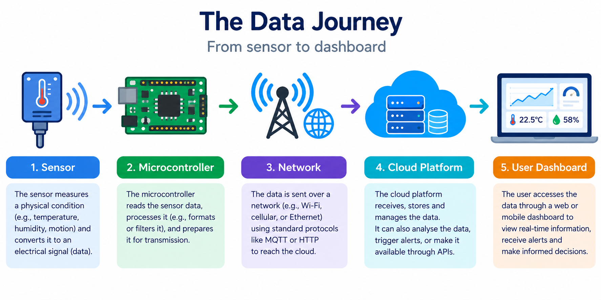

Research-Based Activity 4

Emerging IoT Research Topics
- Answer in your own words and use a suitable, recent example for each topic.
- Where you use external information, record the source in the format your lecturer requests.
- Try to connect at least two of these topics to the practical work you build later in this lab book.
These topics look at where IoT research is heading now. You are not expected to be an expert – a clear, correct paragraph with one good example is enough. Aim for three to six sentences per answer.

1.Edge AI and TinyML. Increasingly, small machine-learning models run directly on microcontrollers rather than in the cloud. In your own words, what are Edge AI and TinyML, and give one reason moving “intelligence” onto the device itself can be an advantage (think latency, cost, privacy or connectivity).

_______________________________________________________________________________________________________________________________________
Edge AI means running AI models (such as image recognition or anomaly detection) directly on the device or a nearby gateway, instead of sending data to the cloud for processing. It typically uses hardware like a Raspberry Pi, a Jetson, or a phone chip with a built-in neural accelerator______________________________________________________________________________________________________________________________________
TinyML is a subset of this: machine learning squeezed down to run on tiny, low-power microcontrollers (such as an ESP32 or Arduino Nano 33 BLE) with only kilobytes of memory and milliwatts of power
_______________________________________________________________________________________________________________________________________

_______________________________________________________________________________________________________________________________________
One advantage, privacy: with on-device processing, raw data such as audio, video or health readings never has to leave the device.

A smart camera can detect a person locally and send only a simple “person detected” alert, so there’s far fewer sensitive data to intercept, leak or store in the cloud. (Latency and working without internet are equally strong reasons, since decisions happen instantly and keep working offline.)
_______________________________________________________________________________________________________________________________________

_______________________________________________________________________________________________________________________________________

_______________________________________________________________________________________________________________________________________

2. AIoT (Artificial Intelligence of Things). How does adding AI or machine learning change what an ordinary IoT system can do? Describe one short example where analysing sensor data with AI is more useful than simply displaying the raw readings.

An ordinary IoT system mostly senses, reports and follows fixed rules (“if temperature > 30°C, send an alert”) _____________________________________________________________________________________________________________________________________

Adding AI or machine learning lets it learn patterns from the data, so it can spot subtle problems, predict what will happen next, adapt to changing conditions and make decisions without someone writing a rule for every situation. _____________________________________________________________________________________________________________________________________

Example, predictive maintenance on a factory motor: Vibration and temperature sensors on the motor produce thousands of readings a day. _____________________________________________________________________________________________________________________________________
Shown as raw numbers or a live graph, they look like noise, and a fixed threshold only fires once the motor is already failing___________________________________________________________________________________________________________________________________

_______________________________________________________________________________________________________________________________________
A machine learning model trained on the motor’s normal behaviour can detect tiny shifts in the vibration pattern that precede a bearing failure and warn, for instance, “likely to fail within about two weeks”.
_______________________________________________________________________________________________________________________________________
Maintenance can then be scheduled during planned downtime, avoiding an unexpected stoppage and costly emergency repair, which no human watching the raw readings could realistically do.
_______________________________________________________________________________________________________________________________________

_______________________________________________________________________________________________________________________________________

3. Digital twins. Define a digital twin in your own words and explain how live data from IoT sensors keeps the twin in step with the real object. Give one industry where digital twins are used.

A digital twin is a virtual representation of a real-world object, system, or process that reflects its condition and behaviour. _____________________________________________________________________________________________________________________________________

How IoT sensors keep it in step: Sensors on the real object continuously collect live data, such as temperature, pressure, or speed, and send it to the digital twin. The twin updates to reflect the real object’s current state, allowing users to monitor performance, detect faults, and predict maintenance needs. _______________________________________________________________________________________________________________________________________
Industry example: Manufacturing, where digital twins of machines are used to monitor performance and predict equipment failures.
_______________________________________________________________________________________________________________________________________

_______________________________________________________________________________________________________________________________________

4. Federated learning for IoT. This trains a shared model across many devices without sending their raw data to a central server. Why is this approach attractive for privacy sensitive IoT applications such as health wearables or smart homes?

_______________________________________________________________________________________________________________________________________
Federated learning is attractive because it improves privacy by keeping raw, sensitive data on the user's device.
______________________________________________________________________________________________________________________________________

Instead of sending personal data to a central server, each device trains the model locally and shares only model updates ______________________________________________________________________________________________________________________________________
This reduces the risk of exposing private information, such as health measurements or smart-home activity, while still allowing devices to collaboratively improve a shared AI model.

_______________________________________________________________________________________________________________________________________

_______________________________________________________________________________________________________________________________________

_______________________________________________________________________________________________________________________________________

_______________________________________________________________________________________________________________________________________

_______________________________________________________________________________________________________________________________________
5. IoT security and lightweight cryptography. Constrained IoT devices cannot always run heavy security. Name two common security threats to IoT systems and describe one lightweight mitigation suitable for a low-power device.

_______________________________________________________________________________________________________________________________________
Unauthorised access: Attackers exploit weak passwords or authentication to gain control of IoT devices.
_______________________________________________________________________________________________________________________________________

_______________________________________________________________________________________________________________________________________
Denial-of-Service (DoS) attacks: Attackers overwhelm a device or network with traffic, disrupting its normal operation.
_______________________________________________________________________________________________________________________________________

_______________________________________________________________________________________________________________________________________
Lightweight mitigation: Use strong device authentication, such as unique passwords or lightweight cryptographic authentication, to prevent unauthorised access without requiring significant processing power or energy.
_______________________________________________________________________________________________________________________________________

_______________________________________________________________________________________________________________________________________

_______________________________________________________________________________________________________________________________________

6. Green and sustainable IoT (including energy harvesting). How can IoT devices reduce their energy use or even run without a conventional battery? Give one example of an energy source a device might harvest (for example light, heat or motion).

_______________________________________________________________________________________________________________________________________
IoT devices can reduce energy use by using low-power components, sleeping when not in use, and transmitting data less frequently. _______________________________________________________________________________________________________________________________________
They can also use energy harvesting to collect energy from their surroundings, potentially operating without a conventional battery.
_______________________________________________________________________________________________________________________________________
Example: A small IoT sensor can harvest energy from indoor or outdoor light using a miniature solar cell to power itself.
_______________________________________________________________________________________________________________________________________

_______________________________________________________________________________________________________________________________________

_______________________________________________________________________________________________________________________________________

_______________________________________________________________________________________________________________________________________

_______________________________________________________________________________________________________________________________________

7. Low-power wide-area connectivity (LoRaWAN, NB-IoT) and 5G. Choose one of these technologies, describe a scenario it is well suited to, and say why (consider range, power use and data rate).

LoRaWAN is well suited to smart agriculture, where sensors monitor soil moisture across large fields. _______________________________________________________________________________________________________________________________________

- Range: Provides long-range communication across large rural areas. _
- Power use: Uses very little energy, allowing battery-powered sensors to operate for years. ________________________________________________________________________.
- Data rate: Supports low data rates, which are sufficient for sending small, periodic soil-moisture readings. ______________________________________________________________________________________________________________________________________

_______________________________________________________________________________________________________________________________________
Therefore, LoRaWAN is ideal for agricultural monitoring because it provides long-range, low-power connectivity without needing to transmit large amounts of data.
_______________________________________________________________________________________________________________________________________

_______________________________________________________________________________________________________________________________________

_______________________________________________________________________________________________________________________________________

_______________________________________________________________________________________________________________________________________
8. Choose your own emerging topic. Pick one further IoT research direction that interests you (for example blockchain for IoT trust, swarm robotics, smart-agriculture prediction, or IoT for healthcare). Summarize what it is and one open challenge researchers are still working on.

_______________________________________________________________________________________________________________________________________
I’ll choose blockchain for IoT trust, since it ties closely to the security themes we’ve covered.
What it is: A blockchain is a shared, tamper-evident ledger, where records are grouped into blocks, linked by cryptographic hashes and copied across many nodes, so changing past entries is very hard without everyone noticing. In IoT, researchers use it to build trust between devices and organisations that don’t fully trust each other, without relying on a single central authority. Examples include logging firmware updates and device identities so only verified devices can join a network, recording sensor readings immutably (such as temperature logs for vaccines or food in transit), and using smart contracts to automate actions, like releasing a payment when a shipment arrives within the right conditions.
One open challenge: the “garbage in, garbage out” problem, combined with resource limits. A blockchain can guarantee that a record hasn’t been altered after it was written, but it can’t guarantee the data was true when it was recorded. If a sensor is faulty, mis calibrated or hacked, the blockchain will faithfully preserve the wrong reading. Trusting the data at the point it is captured (the “oracle problem”) is still unsolved in general, with partial answers such as secure hardware in the device or cross-checking multiple sensors. On top of that, many IoT devices are too small and low-power to run blockchain software, and many blockchains are too slow and energy-hungry for thousands of devices sending frequent readings, so researchers are looking at lightweight consensus methods and gateways that do the heavy work on the devices’ behalf.

_______________________________________________________________________________________________________________________________________

_______________________________________________________________________________________________________________________________________

_______________________________________________________________________________________________________________________________________

_______________________________________________________________________________________________________________________________________

_______________________________________________________________________________________________________________________________________

_______________________________________________________________________________________________________________________________________

_______________________________________________________________________________________________________________________________________

Research skill: read and summarize one paper
Find one short, recent article or paper on any topic above (a reputable magazine article, vendor white paper or conference paper is fine). Complete the table below in your own words. This builds the habit of reading and summarizing sources – a core research skill.
Title | Design and implementation of smart HealthCare system using IoT
Author(s) and year | Durga Amarnath M. Budida, Ram S. Mangrulkar, 2017
Topic (from list above) | IoT for HealthCare
Problem the work addresses | The work addresses patient’s health problem automatically, using IoT
Method or approach used | The method used is first to gather all sensory data that are related to the monitoring of the patients, then store, process and present the resulted information on the server where the doctor can access health reports following the case of the monitored patient.
One key finding or result | One key result is that the health monitoring system is beneficial to the patients as well as to the society where the implementation of such systems will save hospital bill, wait time, and reduce the long queues in the hospitals
One limitation or open question | Data security and patient privacy.
Source / link | https://ieeexplore.ieee.org/abstract/document/8275903

Propose your own research question
Write one research question you would find interesting to investigate with a simple IoT build (for example: “Can a low-cost sensor detect X reliably enough to trigger Y?”). You may use this as inspiration for your Week 11 innovation project.

Research question: Can a low-cost CO₂ sensor reliably detect when a room is occupied, well enough to trigger automatic ventilation or heating changes, compared with a PIR motion sensor? _____________________________________________________________________________________________________________________
Why it’s interesting: PIR sensors only detect movement, so they wrongly report “empty” when someone sits still (studying, sleeping). CO₂ rises with the number of people in a room, so it could be a better occupancy signal, but it responds slowly. That trade-off between accuracy and response time is a good thing to measure.
Simple build
- Microcontroller: ESP32 (built-in Wi-Fi)
- Sensors: an SCD40 or MH-Z19 CO₂ sensor, plus a PIR sensor
- Actuator: an LED or relay to simulate switching a fan or heater
- Data path: publish readings over MQTT to a dashboard (Node-RED or a simple cloud dashboard)
How to test it
- Log both sensors in a room for a few days while you record when it is actually occupied (your ground truth).
- Compare detection accuracy: how often each sensor correctly reports occupied or empty, and how many false “empty” readings the PIR gives.
- Measure the delay between someone entering or leaving and the CO₂ reading crossing your threshold.
- Try combining both sensors (PIR for quick detection, CO₂ for confirming presence) and see if accuracy improves.
What you could conclude: whether CO₂ alone is reliable enough, whether the delay is acceptable for the action it triggers, and whether a combined approach beats either sensor alone.
Extensions: discuss calibration drift in CO₂ sensors, the privacy advantage over cameras, and the security of the MQTT link (TLS and authentication).

_______________________________________________________________________________________________________________________________________

_______________________________________________________________________________________________________________________________________

_______________________________________________________________________________________________________________________________________

_______________________________________________________________________________________________________________________________________

Tinkercad-Based Activities
Simulate circuits, test logic and explain how the code works

- Create or use your Tinkercad account as instructed by your lecturer.
- Complete the circuit, run the simulation and capture suitable evidence.
- For each task, explain the code function and complete the challenge where possible.

- Write a short paragraph explaining what Tinkercad is and how it can be used for IoT and Arduino learning.

Tinkercad is a free, browser-based tool from Autodesk for 3D design, electronics and coding, and its Circuits feature is especially useful for learning IoT and Arduino. ____________________________________________________________________________________________________________________________
It lets you build virtual circuits by dragging an Arduino board, breadboard, LEDs, resistors, sensors (such as
_______________________________________________________________________________________________________________________________________
temperature, PIR and ultrasonic) and actuators (motors, servos, buzzers) onto a workspace, then write code in ______________________________________________________________________________________________________________________________________
text or block form and run a simulation to see the circuit respond, much like your LED sketch would.

_______________________________________________________________________________________________________________________________________

_______________________________________________________________________________________________________________________________________

_______________________________________________________________________________________________________________________________________

_______________________________________________________________________________________________________________________________________

_______________________________________________________________________________________________________________________________________

_______________________________________________________________________________________________________________________________________

_______________________________________________________________________________________________________________________________________

_______________________________________________________________________________________________________________________________________

_______________________________________________________________________________________________________________________________________

_______________________________________________________________________________________________________________________________________

2. Initial reflection: What do you expect to learn from circuit simulation before moving to physical hardware?
_______________________________________________________________________________________________________________________________________
I expect to learn how the basic parts of a circuit fit together: how a microcontroller pin connects to an LED, ____________________________________________________________________________________________________________________________________
button or sensor, why each component needs a resistor, and how power and ground are wired. Simulation
_______________________________________________________________________________________________________________________________________
should let me test my code and logic first. I can check that the sensor readings are read correctly, that the
_______________________________________________________________________________________________________________________________________
actuator responds at the right threshold, and that my digitalWrite, analogRead and delay timings behave as intended, with the serial monitor helping me debug. ____________________________________________________________________________________________________________________________________

_______________________________________________________________________________________________________________________________________

_______________________________________________________________________________________________________________________________________

_______________________________________________________________________________________________________________________________________

_______________________________________________________________________________________________________________________________________

_______________________________________________________________________________________________________________________________________

_______________________________________________________________________________________________________________________________________

Task 2: Arduino One LED Light Setup

Aim: Build and program one LED to blink at a fixed interval.

Circuit / Build Evidence  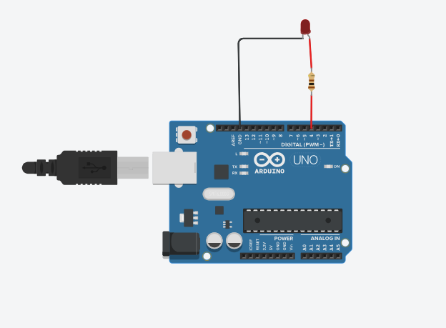  Components used: Arduino UNO R3, 1 red LED, 1 kΩ resistor, wire connectors | #define led 4  void setup() {  pinMode(led, OUTPUT);  }  void loop() {  digitalWrite(led, HIGH);  delay(3000);  digitalWrite(led, LOW);  delay(1000);  }
Results / Observations  _______________________________________  When I ran the simulation, the LED connected to digital pin 4 of the Arduino turned ON for 3 seconds and then OFF for 1 second. This process repeated continuously because the instructions were placed inside the loop() function.  Result: The LED blinks repeatedly, staying ON for 3 seconds and OFF for 1 second, completing one cycle every 4 seconds. | Reflection / Code Function  The pinMode(led, OUTPUT) instruction configures pin 4 as an output, while digitalWrite(led, HIGH) turns the LED on and digitalWrite(led, LOW) turns it off.  The delay(3000) instruction pauses for 3,000 milliseconds (3 seconds), and delay(1000) pauses for 1,000 milliseconds (1 second).  Challenge: Change the delay to create two different blink patterns.

Task 3: Arduino Three LED Light Setup
Aim: Control three outputs in sequence.
Circuit / Build Evidence  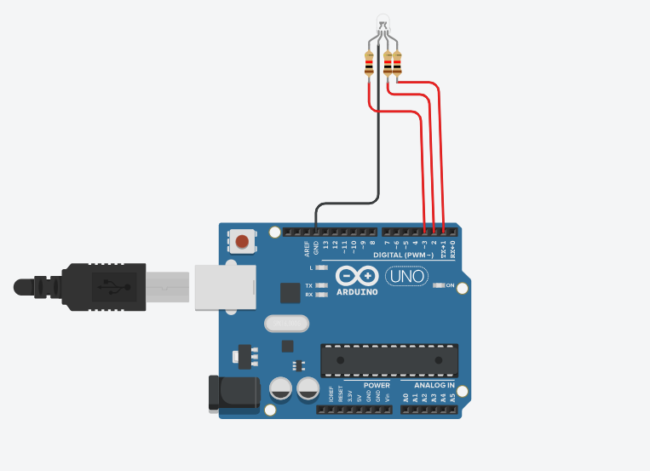  Components used: Arduino UNO R3, 3 LEDs or RGB LED, resistors, wire connectors | #define green 1  #define blue 2  #define red 3  void setup() {  pinMode(green, OUTPUT);  pinMode(blue, OUTPUT);  pinMode(red, OUTPUT);  }  void loop() {  digitalWrite(green,HIGH); delay(500);  digitalWrite(green,LOW);  digitalWrite(blue,HIGH); delay(500);  digitalWrite(blue,LOW);  digitalWrite(red,HIGH); delay(500);  digitalWrite(red,LOW);  }
Results / Observations  ____________________________________________  When I ran the simulation, the green, blue, and red LEDs illuminated one after another in sequence. The green LED turned on for 0.5 seconds and then turned off, followed by the blue LED for 0.5 seconds, and then the red LED for 0.5 seconds. This sequence repeated continuously because the instructions were placed inside the loop() function.  Results: The simulation demonstrated that the Arduino could control three LEDs independently using digital output pins 1, 2, and 3. Each LED illuminated for 500 milliseconds before switching off and allowing the next LED to turn on. The complete sequence took approximately 1.5 seconds per cycle. | Reflection / Code Function  _____________________________________________  The purpose of the code is to control three LEDs connected to Arduino digital pins 1, 2, and 3. Each LED turns on for 500 milliseconds (0.5 seconds) and then turns off before the next LED illuminates. The sequence repeats continuously.  - #define green 1, #define blue 2, and #define red 3: Assign names to the digital pins.  - pinMode(pin, OUTPUT): Configures each pin as an output.  - digitalWrite(LED, HIGH): Turns the selected LED on.  - delay(500): Keeps the program paused for 0.5 seconds.  - digitalWrite(LED, LOW): Turns the selected LED off.  - void loop(): Repeats the LED sequence continuously.  Challenge: Create a traffic-style sequence with realistic timing.

Task 4: Arduino Seven-Colour RGB Setup

Aim: Use RGB mixing to generate multiple colours.

Circuit / Build Evidence  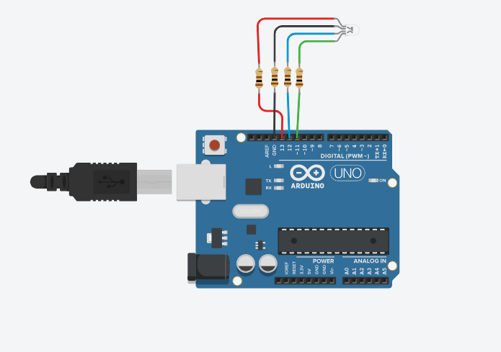  Components used: Arduino UNO R3, RGB LED, resistors, wire connectors | const int redPin = 13;  const int greenPin = 11;  const int bluePin = 12;  void setup() {  pinMode(redPin, OUTPUT);  pinMode(greenPin, OUTPUT);  pinMode(bluePin, OUTPUT);  }  void setColor(int r,int g,int b){  analogWrite(redPin,r);  analogWrite(greenPin,g);  analogWrite(bluePin,b);  }  void loop(){  setColor(255,0,0); delay(1000);  setColor(0,255,0); delay(1000);  setColor(0,0,255); delay(1000);  setColor(0,255,255); delay(1000);  setColor(255,0,255); delay(1000);  setColor(255,255,0); delay(1000);  setColor(255,255,255); delay(1000);  }
Results / Observations  When I ran the simulation, the three LEDs lit one after another in a repeating sequence: green for half a second, then blue, then red, then back to green. Only one LED was on at a time, and the cycle took 1.5 seconds. The sequence ran continuously until I stopped the simulation. | Reflection / Code Function  This exercise helped me understand the basic pattern of embedded programming: configure the pins once, then repeatedly set outputs and wait. Each LED is switched off before the next one turns on, so the colours don’t overlap. It also showed me how outputs are controlled by software, which is the same principle as an actuator in an IoT system.  - #define green 13, #define blue 11 and #define red 12 give each LED a readable name linked to a pin number, which makes the code easier to follow.  - pinMode(..., OUTPUT) in setup () runs once and sets each pin as an output so the Arduino can send current to the LEDs.  - digitalWrite(pin, HIGH) turns an LED on by sending 5 V to its pin, and digitalWrite(pin, LOW) turns it off.  - delay(500) pauses the program for 500 ms, so each LED stays lit for half a second.  loop () repeats the on/off sequence forever, which creates the traffic-light-style chase effect  Challenge: Create a colour that is not listed and explain the RGB values used.

Task 5: Arduino LED with Two Switches
Aim: Use two digital inputs to control one output.
Circuit / Build Evidence  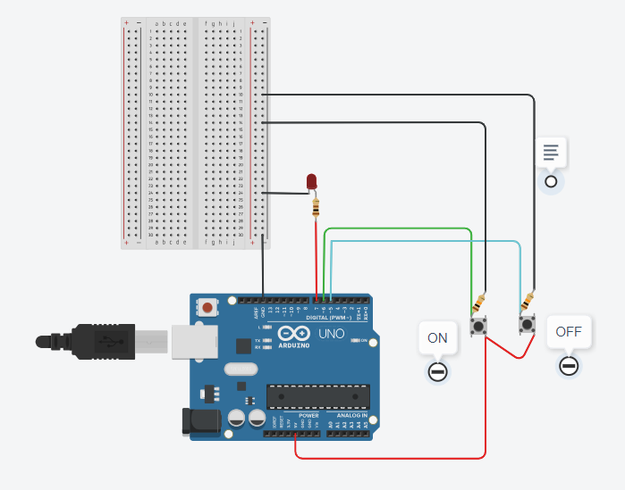  Components used: Arduino UNO R3, red LED, breadboard, 2 push buttons, resistors, wire connectors | #define red 7  #define onButton 6  #define offButton 5  void setup(){  pinMode(red, OUTPUT);  pinMode(onButton, INPUT);  pinMode(offButton, INPUT);  }  void loop(){  int onState = digitalRead(onButton);  int offState = digitalRead(offButton);  if(onState == HIGH) digitalWrite(red,HIGH);  if(offState == HIGH) digitalWrite(red,LOW);  }
Results / Observations  When I ran the simulation, the red LED stayed off at first. When I pressed the “on” button, the LED turned on and stayed on even after I released the button. When I pressed the “off” button, it turned off and stayed off. The LED only changed state when one of the buttons was pressed. | Reflection / Code Function  This exercise showed me the difference between an output (the LED) and an input (the buttons), and how a program can read an input and act on it. It is the same sense, decide, act loop as an IoT system: the buttons act like sensors, the if statements are the decision logic, and the LED is the actuator. It also shows state: the LED “remembers” whether it is on or off, because the code only changes it when a button is pressed.  - #define red 7, #define onButton 6 and #define offButton 5 give the LED and the two buttons readable names linked to pin numbers.  - pinMode(red, OUTPUT) sets pin 7 as an output so the Arduino can drive the LED.  - pinMode(onButton, INPUT) and pinMode(offButton, INPUT) set pins 6 and 5 as inputs so the Arduino can read the buttons.  - digitalRead() checks whether each button pin is HIGH (pressed) or LOW (not pressed), and stores the result in onState and offState.  - The if statements are the decision-making: if the on button reads HIGH, the LED is set HIGH, and if the off button reads HIGH, it is set LOW.  - loop() runs these checks over and over, so the Arduino keeps watching the buttons.  Challenge: Add Serial Monitor messages showing ON and OFF events.

Task 6: Arduino LED with One Toggle Switch
Aim: Use one push button to toggle an LED state.
Circuit / Build Evidence  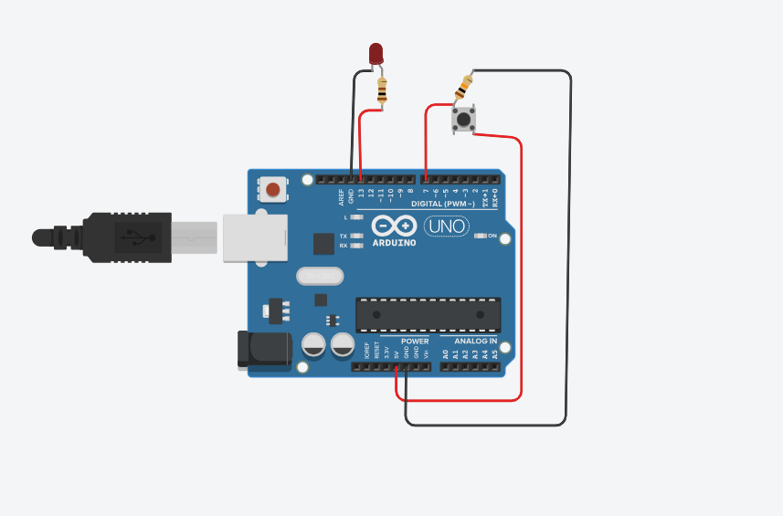  Components used: Arduino UNO R3, red LED, push button, resistors, wire connectors | #define led 13  #define buttonPin 7  int lastState = 0;  void setup(){  pinMode(led, OUTPUT);  pinMode(buttonPin, INPUT);  }  void loop(){  int value = digitalRead(buttonPin);  if(value == HIGH){  lastState = !lastState;  digitalWrite(led,lastState);  delay(200);  }  }
Results / Observations  _______________________________________________________________________________  _______________________________________________________________________________  _______________________________________________________________________________  _______________________________________________________________________________  _______________________________________________________________________________  _______________________________________________________________________________  _______________________________________________________________________________  _______________________________________________________________________________  _______________________________________________________________________________  ________________________________________ | Reflection / Code Function  __________________________________________________________________________________  __________________________________________________________________________________  __________________________________________________________________________________  __________________________________________________________________________________  __________________________________________________________________________________  __________________________________________________________________________________  Challenge: Improve the button behaviour using a better debounce method.

Task 7: IoT Traffic Light Simulation with Pedestrian Button
Aim: Model a simple smart crossing controlled by user input.
Circuit / Build Evidence  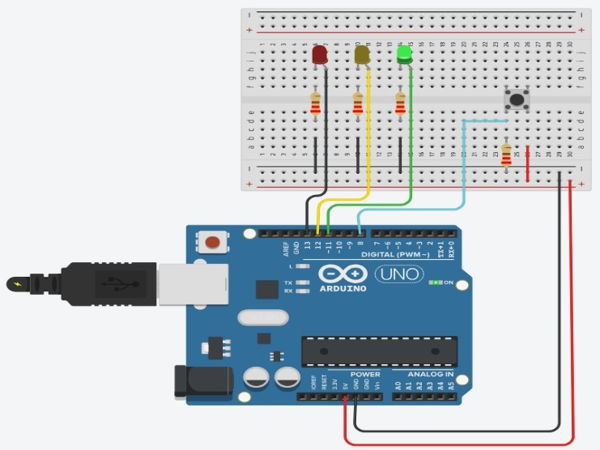  Components used: Arduino UNO R3, 3 LEDs, push button, 220 Ω resistors, wire connectors | int greenLed=11, amberLed=12, redLed=13;  int pushButton=8;  void setup(){  pinMode(greenLed,OUTPUT);  pinMode(amberLed,OUTPUT);  pinMode(redLed,OUTPUT);  pinMode(pushButton,INPUT);  Serial.begin(9600);  }  void loop(){  int request=digitalRead(pushButton);  if(request==LOW){  digitalWrite(greenLed,HIGH);  digitalWrite(amberLed,LOW);  digitalWrite(redLed,LOW);  } else {  Serial.println("PEDESTRIAN WAITING");  digitalWrite(greenLed,LOW);  digitalWrite(amberLed,HIGH); delay(2000);  digitalWrite(amberLed,LOW);  digitalWrite(redLed,HIGH);  Serial.println("PEDESTRIAN CROSSING");  delay(5000);  }  }
Results / Observations  _______________________________________________________________________________  _______________________________________________________________________________  _______________________________________________________________________________  _______________________________________________________________________________  ________________________________________________________________________________________________________________________________________________________________ | Reflection / Code Function  __________________________________________________________________________________  __________________________________________________________________________________  __________________________________________________________________________________  __________________________________________________________________________________  __________________________________________________________________________________  Challenge: Add a timed return to green and a countdown concept.
Task 8: Arduino Temperature Sensor Setup
Aim: Read an analogue temperature sensor and convert the signal to degrees Celsius.
Circuit / Build Evidence  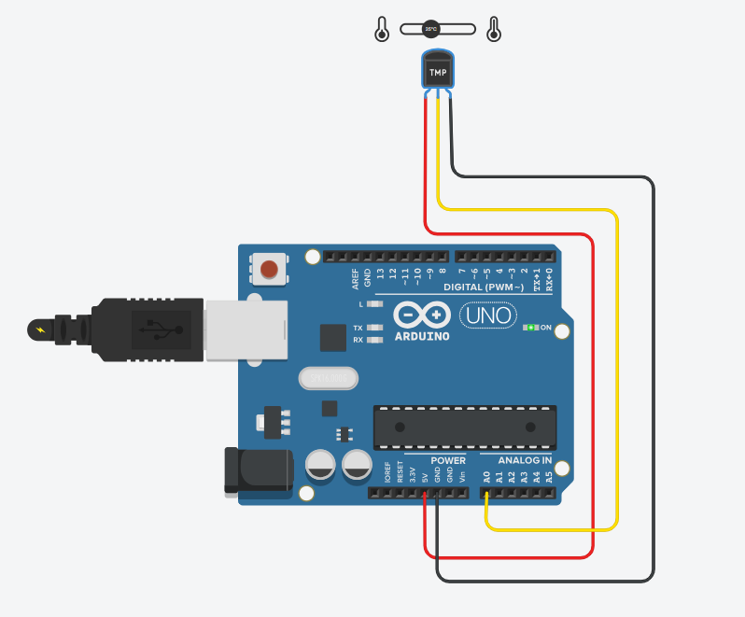  Components used: Arduino UNO R3, TMP36 temperature sensor, wire connectors | void setup(){  pinMode(A0, INPUT);  Serial.begin(9600);  }  void loop(){  int signal=analogRead(A0);  float voltage=signal*(5000.0/1024.0);  float temperature=(voltage-500)/10.0;  Serial.println(temperature);  delay(500);  }
Results / Observations  _______________________________________________________________________________  _______________________________________________________________________________  _______________________________________________________________________________  _______________________________________________________________________________  _______________________________________________________________________________  _______________________________________________________________________________  _______________________________________________________________________________ | Reflection / Code Function  __________________________________________________________________________________  __________________________________________________________________________________  __________________________________________________________________________________  __________________________________________________________________________________  __________________________________________________________________________________  __________________________________________________________________________________  Challenge: Add an LED warning when the temperature exceeds a threshold.

Task 9: Arduino LDR Sensor Setup
Aim: Read changing light levels using an analogue sensor.
Circuit / Build Evidence  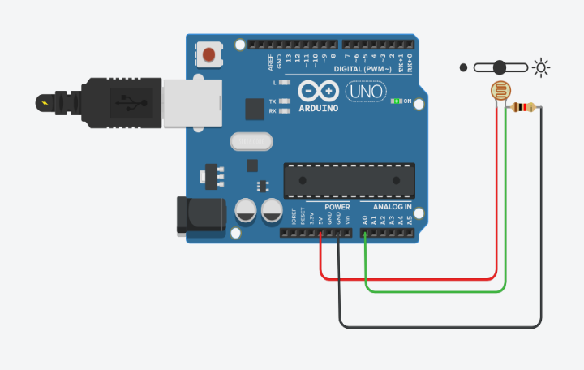  Components used: Arduino UNO R3, LDR photoresistor, 1 kΩ resistor, wire connectors | #define ldr A0  void setup(){  pinMode(ldr,INPUT);  Serial.begin(9600);  }  void loop(){  int value=analogRead(ldr);  Serial.println(value);  delay(1000);  }
Results / Observations  _______________________________________________________________________________  _______________________________________________________________________________  _______________________________________________________________________________  _______________________________________________________________________________  _______________________________________________________________________________  _______________________________________________________________________________  _______________________________________________________________________________  _______________________________________________________________________________ | Reflection / Code Function  __________________________________________________________________________________  __________________________________________________________________________________  __________________________________________________________________________________  __________________________________________________________________________________  __________________________________________________________________________________  __________________________________________________________________________________  Challenge: Use the LDR value to switch an LED automatically in low light.

Task 10: Gas Sensor and Buzzer
Aim: Create a threshold-based alarm from a sensor reading.
Circuit / Build Evidence  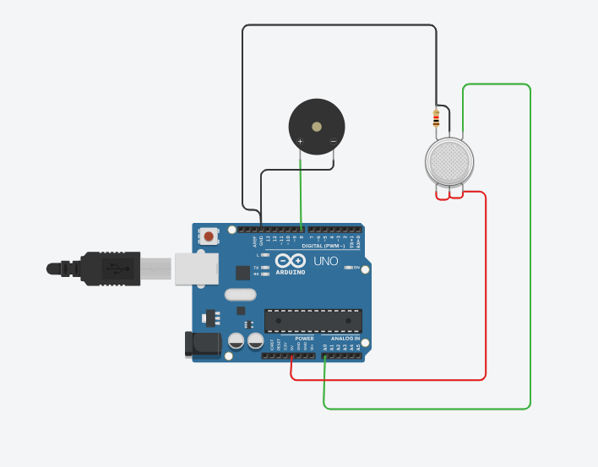  Components used: Arduino UNO R3, gas sensor, piezo buzzer, 1 kΩ resistor, wire connectors | #define gasSensor A0  #define buzzer 8  void setup(){  pinMode(gasSensor,INPUT);  pinMode(buzzer,OUTPUT);  Serial.begin(9600);  }  void loop(){  int value=analogRead(gasSensor);  Serial.println(value);  if(value>100){  tone(buzzer,8000); delay(500);  noTone(buzzer);  }  delay(500);  }
Results / Observations  _______________________________________________________________________________  _______________________________________________________________________________  _______________________________________________________________________________  _______________________________________________________________________________  _______________________________________________________________________________  _______________________________________________________________________________  _______________________________________________________________________________  _______________________________________________________________________________ | Reflection / Code Function  __________________________________________________________________________________  __________________________________________________________________________________  __________________________________________________________________________________  __________________________________________________________________________________  __________________________________________________________________________________  __________________________________________________________________________________  Challenge: Use two thresholds to produce warning and danger states.

Task 11: LED Brightness with Potentiometer
Aim: Convert an analogue input into PWM output control.
Circuit / Build Evidence  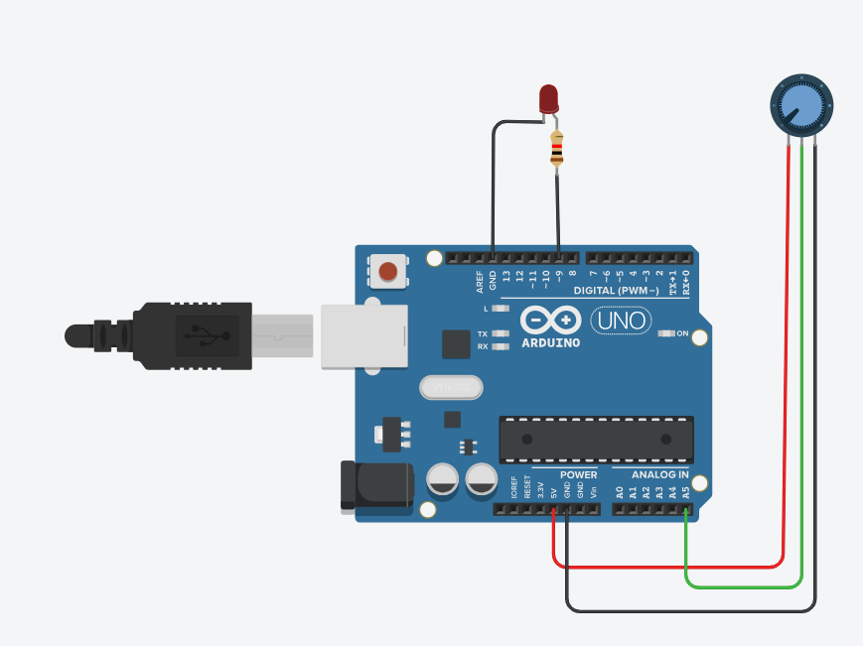  Components used: Arduino UNO R3, LED, potentiometer, resistor, wire connectors | #define led 9  #define pot A5  void setup(){  pinMode(led,OUTPUT);  pinMode(pot,INPUT);  Serial.begin(9600);  }  void loop(){  int value=analogRead(pot);  int brightness=map(value,0,1023,0,255);  analogWrite(led,brightness);  Serial.println(value);  delay(50);  }
Results / Observations  _______________________________________________________________________________  _______________________________________________________________________________  _______________________________________________________________________________  _______________________________________________________________________________  _______________________________________________________________________________  _______________________________________________________________________________  _______________________________________________________________________________  _______________________________________________________________________________  _______________________________________________________________________________ | Reflection / Code Function  __________________________________________________________________________________  __________________________________________________________________________________  __________________________________________________________________________________  __________________________________________________________________________________  __________________________________________________________________________________  _________________________________________________________________________________________________________________________________________________  Challenge: Display both the raw input and mapped brightness value.

Task 12: LCD Message Display
Aim: Display information locally on an IoT device.
Circuit / Build Evidence  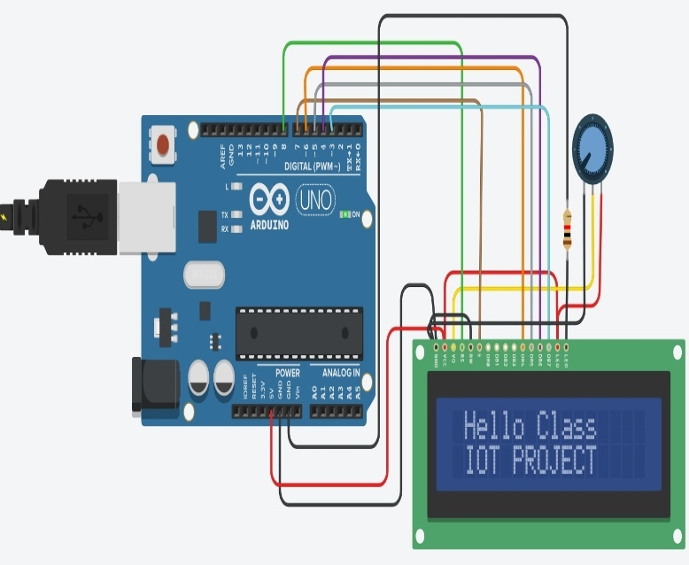  Components used: Arduino UNO R3, 16x2 LCD, potentiometer, resistor, wires | #include <LiquidCrystal.h>  LiquidCrystal lcd(8,7,6,5,4,3);  void setup(){  lcd.begin(16,2);  }  void loop(){  lcd.setCursor(0,0);  lcd.print("Hello Class");  lcd.setCursor(0,1);  lcd.print("IoT Project");  }
Results / Observations  _______________________________________________________________________________  _______________________________________________________________________________  _______________________________________________________________________________  _______________________________________________________________________________  _______________________________________________________________________________  _______________________________________________________________________________  _______________________________________________________________________________  _______________________________________________________________________________  _______________________________________________________________________________  ________________________________________ | Reflection / Code Function  __________________________________________________________________________________  __________________________________________________________________________________  __________________________________________________________________________________  __________________________________________________________________________________  __________________________________________________________________________________  _____________________________________________________________________________________________________________________________________________________________________________________________________________  Challenge: Replace the fixed message with a live sensor value.

Task 13: Ultrasonic Sensor with Buzzer and RGB Indication
Aim: Measure distance and use the reading to trigger different outputs.
Circuit / Build Evidence  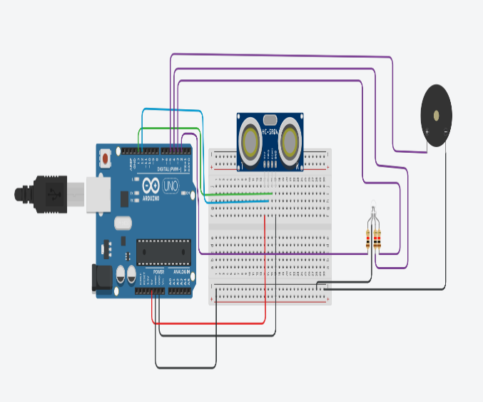  Components used: Arduino UNO R3, ultrasonic sensor, buzzer, RGB LED, breadboard, resistors, wire connectors | const int trigPin=12;  const int echoPin=13;  #define buzzer 5  #define red 2  #define green 3  #define blue 4  long duration;  int distance;  void setup(){  pinMode(trigPin,OUTPUT);  pinMode(echoPin,INPUT);  pinMode(buzzer,OUTPUT);  pinMode(red,OUTPUT);  pinMode(green,OUTPUT);  pinMode(blue,OUTPUT);  Serial.begin(9600);  }  void loop(){  digitalWrite(trigPin,LOW); delayMicroseconds(2);  digitalWrite(trigPin,HIGH); delayMicroseconds(10);  digitalWrite(trigPin,LOW);  duration=pulseIn(echoPin,HIGH);  distance=duration*0.034/2;  Serial.println(distance);  }
Results / Observations  _______________________________________________________________________________  _______________________________________________________________________________  _______________________________________________________________________________  _______________________________________________________________________________  _______________________________________________________________________________  _______________________________________________________________________________  _______________________________________________________________________________  _______________________________________________________________________________  _______________________________________________________________________________  _______________________________________________________________________________________________________________________________________________________________________________________________________________________________________ | Reflection / Code Function  __________________________________________________________________________________  __________________________________________________________________________________  __________________________________________________________________________________  __________________________________________________________________________________  __________________________________________________________________________________  ________________________________________________________________________________________________________________________________________________________________________________________________________________________________________________________________________________________________________________________________________________________________________________________________________________________________________________________________________________________________________________________________________  Challenge: Create three distance zones with green, blue, and red indicators.

Task 14: NeoPixel LED Control with Arduino
Aim: Control addressable LEDs programmatically.
Circuit / Build Evidence  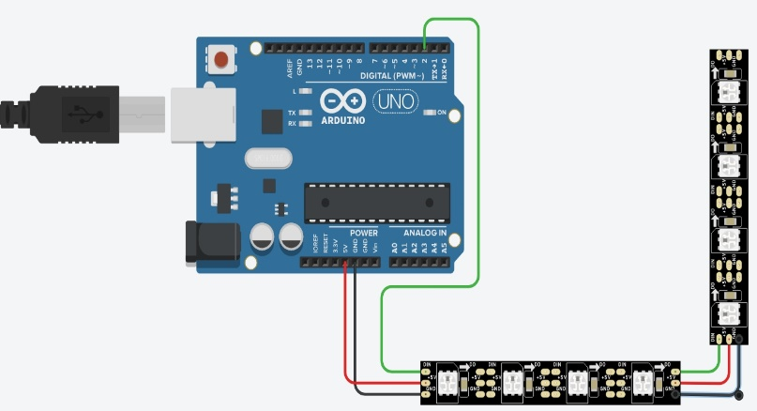  Components used: Arduino UNO R3, NeoPixel strip, wires | #include <Adafruit_NeoPixel.h>  #define PIN 2  #define NUMPIXELS 8  Adafruit_NeoPixel pixels(NUMPIXELS,PIN,NEO_GRB+NEO_KHZ800);  void setup(){  pixels.begin();  }  void loop(){  for(int i=0;i<NUMPIXELS;i++){  int r=random(0,255);  int g=random(0,255);  int b=random(0,255);  pixels.setPixelColor(i,pixels.Color(r,g,b));  pixels.show();  delay(100);  }  }
Results / Observations  _______________________________________________________________________________  _______________________________________________________________________________  _______________________________________________________________________________  _______________________________________________________________________________  _______________________________________________________________________________  _______________________________________________________________________________  _______________________________________________________________________________  ________________________________________  _______________________________________________________________________________ | Reflection / Code Function  _______________________________________________________________________________  _______________________________________________________________________________  _______________________________________________________________________________  _______________________________________________________________________________  _______________________________________________________________________________  _______________________________________________________________________________  Challenge: Create a meaningful status pattern for an IoT device (normal, warning, fault).

Practical Lab Work
Build physical IoT systems using Arduino MKR WiFi 1010 and connected components

- Insert your own lab photograph or screenshot where requested.
- Record measured values rather than only saying that the circuit worked.
- Explain problems, corrections and improvements in your reflection.

Task 1: Arduino MKR WiFi 1010 with 3 LED Lights
Aim: Build and test three independent digital outputs.
Circuit / Build Evidence  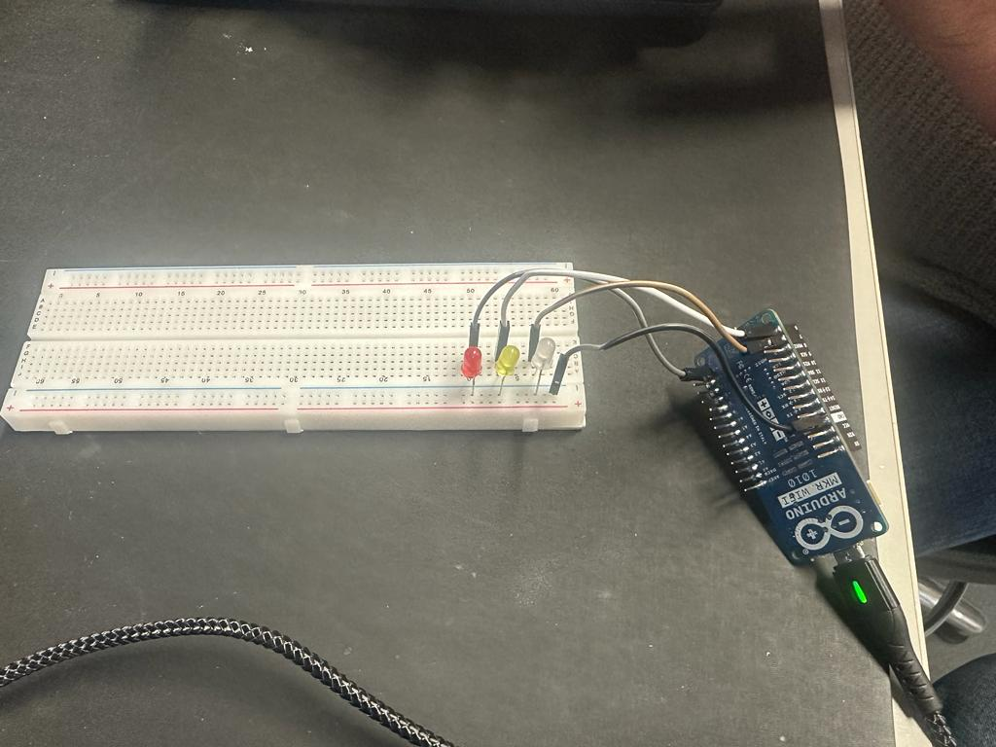  Components used: Breadboard, 3 LEDs, Arduino MKR WiFi 1010 | Code / Flowchart  __________________________________________________________________________________  __________________________________________________________________________________  __________________________________________________________________________________  __________________________________________________________________________________  __________________________________________________________________________________  __________________________________________________________________________________  __________________________________________________________________________________  __________________________________________________________________________________  __________________________________________________________________________________
Results / Observations  ________________________________________________________________________________  ________________________________________________________________________________  ________________________________________________________________________________  ________________________________________________________________________________  ________________________________________________________________________________  ________________________________________________________________________________  ________________________________________________________________________________  ________________________________________________________________________________  ________________________________________________________________________________ | Reflection / Code Function  __________________________________________________________________________________  __________________________________________________________________________________  __________________________________________________________________________________  __________________________________________________________________________________  __________________________________________________________________________________  __________________________________________________________________________________  Challenge: Create a reusable function that controls the three LEDs.  Real-world link: Status indicator for a connected device.

Task 2: DHT22 Temperature and Humidity with 2 LED Lights
Aim: Read temperature and humidity and indicate status using LEDs.
Circuit / Build Evidence  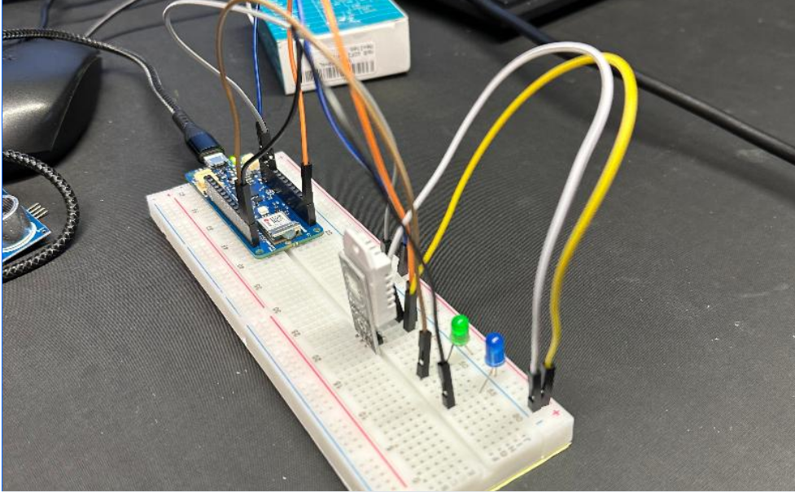  Components used: Arduino MKR WiFi 1010, DHT22 sensor, 2 LEDs, breadboard, wire connectors | Code / Flowchart  __________________________________________________________  __________________________________________________________  __________________________________________________________  __________________________________________________________  __________________________________________________________  __________________________________________________________  __________________________________________________________  __________________________________________________________  __________________________________________________________
Results / Observations  ________________________________________________________________________________  ________________________________________________________________________________  ______________________________________________________________________________________________________________________________________________________________________________________________________________________________________________________________________________________________________________________________________________________________________________________________________________________________________________________________________________________________ | Reflection / Code Function  __________________________________________________________________________________  __________________________________________________________________________________  __________________________________________________________________________________  __________________________________________________________________________________  __________________________________________________________________________________  __________________________________________________________________________________  Challenge: Define your own normal and warning thresholds and justify them.  Real-world link: Environmental monitoring in a smart room.

Task 3: Soil Moisture Sensor with 2 LED Lights
Aim: Measure soil moisture and show a simple wet/dry status.
Circuit / Build Evidence  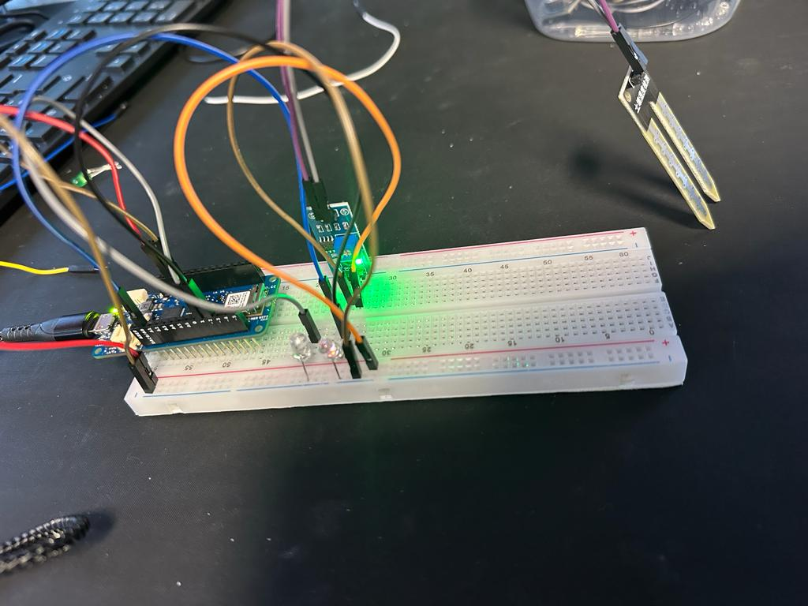  Components used: Arduino MKR WiFi 1010, soil moisture sensor, 2 LEDs, breadboard, wire connectors | Code / Flowchart  __________________________________________________________________________________________________________________________________________________________________________________________________________________________________________________________________________________________________________________________________________________________________________________________________________________________________________________________________________________________________________________________________________________________________________________________________________________________________________________________________________________________________________________________________________________________________________________________________________________________________________________________________________________________________________________________________
Results / Observations  ________________________________________________________________________________________________________________________________________________________________________________________________________________________________________________________________________________________________________________________________________________________________________________________________________________________________________________________________________________________________________________________________________________________________________________________________________________________________________________________________ | Reflection / Code Function  _____________________________________________________________________________________________________________________________________________________________________________________________________________________________________________________________________________________________________________________________________________________________________________________________________________________________________________________________________________________________________________________________________________________Challenge: Calibrate dry and wet readings before choosing a threshold.  Real-world link: Smart agriculture and plant care.

Task 4: Gas Sensor with MKR WiFi 1010
Aim: Use a gas sensor reading to generate visual warning states.
Circuit / Build Evidence  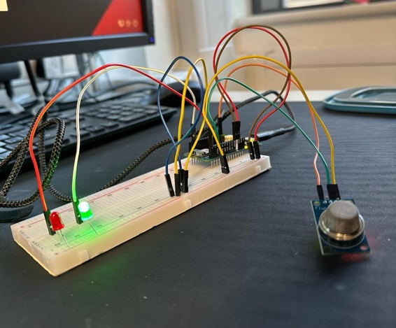  Components used: Arduino MKR WiFi 1010, gas sensor, 2 LEDs, breadboard, wire connectors | Code / Flowchart  ______________________________________________________________________________________________________________________________________________________________________________________________________________________________________________________________________________________________________________________________________________________________________________________________________________________________________________________________________________________________________________________________________________________________________________________________________________________________________________________________________________________________________________________________________________________________________________________________________________________________________________________________________________________________________________________________________________________________________________________________________________________
Results / Observations  ________________________________________________________________________________________________________________________________________________________________________________________________________________________________________________________________________________________________________________________________________________________________________________________________________________________________________________________  __________________________________________________________ | Reflection / Code Function  ___________________________________________________________________________________________________________________________________________________________________________________________________________________________________________________________________________________________________________________________________________________________________________________________________________________________________________________________________  Challenge: Add a buzzer or cloud alert for the high-risk state.  Real-world link: Air-quality and safety monitoring.

Task 5: OLED Adafruit SH1106G Display
Aim: Display text and device information on an OLED screen.
Circuit / Build Evidence  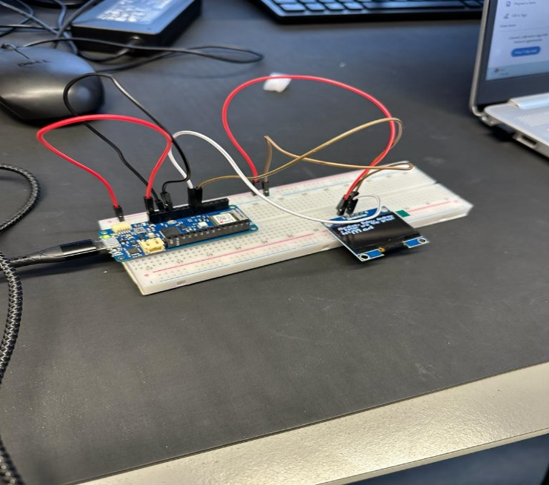  Components used: Arduino MKR WiFi 1010, OLED Adafruit SH1106G, breadboard, wire connectors | Code / Flowchart  ____________________________________________________________________________________________________________________________________________________________________________________________________________________________________________________________________________________________________________________________________________________________________________________________________________________________________________________________________________________________________________________________________________________________________________________________________________________________________________________________________________________________________________________________________________________________________________________________________
Results / Observations  ________________________________________________________________________________________________________________________________________________________________________________________________________________________________________________________________________________________________________________________________________________________________________  ________________________________________________________________________________________________________________________________________________________________________________________________________________________________________________________________________________________________ | Reflection / Code Function  ______________________________________________________________________________________________________________________________________________________________________________________________________________________________________________________________________________________________________________________________________________________________________________________________________________________________________________________________________________________________________________________________________________________________________________________________  Challenge: Show a changing sensor value with a clear label and unit.  Real-world link: Local user interface for an IoT node.

Task 5b: OLED SH1106G with Soil Moisture Sensor
Aim: Combine sensing and local visualisation in one system.
Circuit / Build Evidence  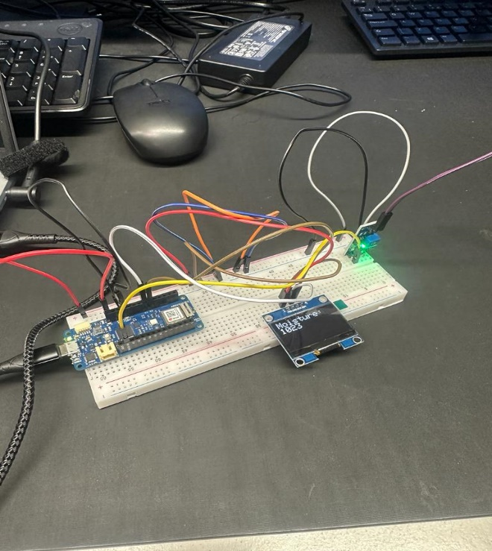  Components used: Arduino MKR WiFi 1010, OLED SH1106G, soil moisture sensor, breadboard, wire connectors | Code / Flowchart  _______________________________________________________________________________________________________________________________________________________________________________________________________________________________________________________________________________________________________________________________________________________________________________________________________________________________________________________________________________________________________________________________________________________________________________________________________________________________________________________________________________________________________________________________________________________________________________________________________________________________________________________________________________________________________________________________________________________
Results / Observations  ________________________________________________________________________________________________________________________________________________________________________________________________________________________________________________________________________________________________________________________________________________________________________________________________________________________________________________________________________________________________________________________________________________________ | Reflection / Code Function  ___________________________________________________________________________________________________________________________________________________________________________________________________________________________________________________________________________________________________________________________________________________________________________________________________________________________________________________________________  Challenge: Display both the raw sensor reading and a percentage or status.  Real-world link: Smart plant monitoring.

Task 6: Controlling Devices Through the Cloud - RGB LED
Aim: Control a physical output remotely using a cloud interface.
Circuit / Build Evidence  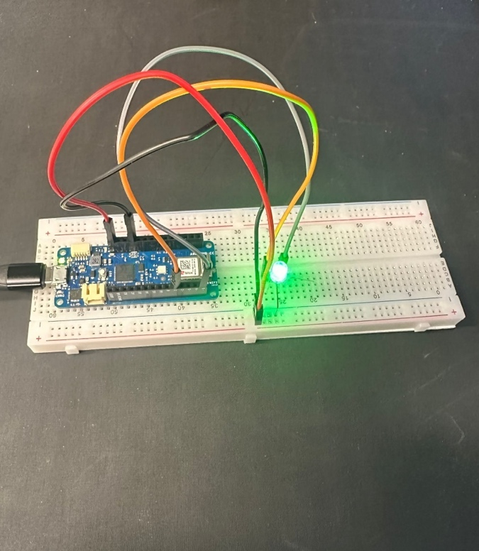  Components used: Arduino MKR WiFi 1010, RGB LED, breadboard, wire connectors | Code / Flowchart  _______________________________________________________________________________________________________________________________________________________________________________________________________________________________________________________________________________________________________________________________________________________________________________________________________________________________________________________________________________________________________________________________________________________________________________________________________________________________________________________________________________________________________________________________________________________________________________________________________________________________________________________________________________________________________________________________________________________
Results / Observations  ____________________________________________________________________________________________________________________________________________________________________________________________________________________________________________________________________________________________________________________________________________________________________________________________________________________________________________________________________________________________________________________________________________________________________________________________________________________________________________ | Reflection / Code Function  ______________________________________________________________________________________________________________________________________________________________________________________________________________________________________________________________________________________________________________________________________________________________________________________________________________________________________________________________________________________________  Challenge: Add three remote commands: normal, warning and off.  Real-world link: Remote control of connected equipment.

Task 7: Monitoring Temperature and Humidity Through the Cloud
Aim: Send live sensor data to a cloud platform for remote monitoring.
Circuit / Build Evidence  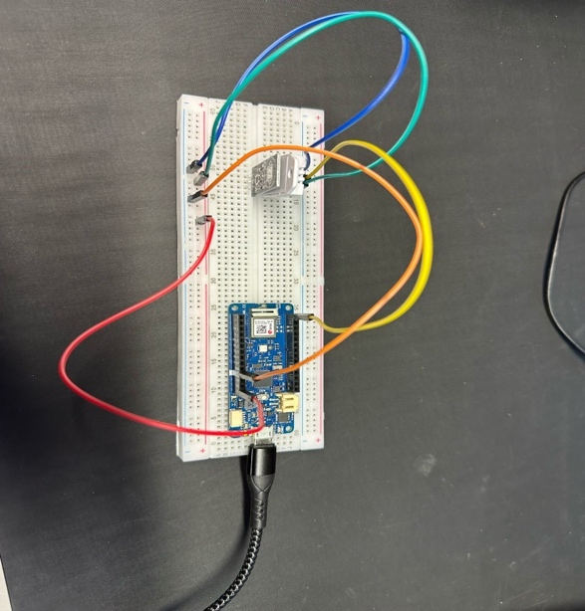  Components used: Arduino MKR WiFi 1010, DHT22 sensor, breadboard, wire connectors | Code / Flowchart  ________________________________________________________________________________________________________________________________________________________________________________________________________________________________________________________________________________________________________________________________________________________________________________________________________________________________________________________________________________________________________________________________________________________________________________________________________________________________________________________________________________________________________________________________________________________________________________________________________________________
Results / Observations  ________________________________________________________________________________________________________________________________________________________________________________________________________________________________________________________________________________________________________________________________________________________________________________________________________________________________________________________________________________________________________________________________________  _______________________________________________________________________________ | Reflection / Code Function  ____________________________________________________________________________________________________________________________________________________________________________________________________________________________________________________________________________________________________________________________________________________________________________________________________________________________________________________________________________________________________________  Challenge: Create a graph and comment on changes over time.  Real-world link: Remote building/environment monitoring.

Task 8: MKR WiFi 1010 with LDR and Servo Motor
Aim: Use a sensor value to control a physical actuator.
Circuit / Build Evidence  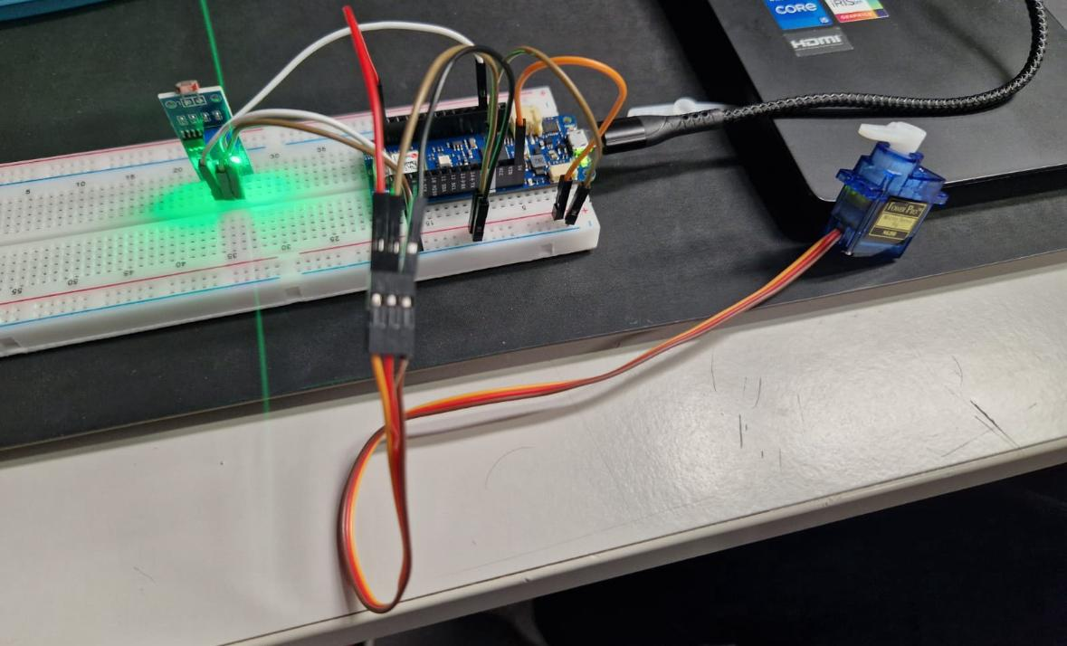  Components used: Arduino MKR WiFi 1010, LDR, servo motor, breadboard, wire connectors | Code / Flowchart  ___________________________________________________________________________________________________________________________________________________________________________________________________________________________________________________________________________________________________________________________________________________________________________________________________________________________________________________________________________________________________________________________________________________________________________________________________________________________________________________________________________________________________________________________________________________________________________________________________________
Results / Observations  _____________________________________________________________________________________________________________________________________________________________________________________________________________________________________________________________________________________________________________________________________________________________________________________________________________________________________________________________________________________________________________________________________________________________________________________________________________________________________________________________ | Reflection / Code Function  ____________________________________________________________________________________________________________________________________________________________________________________________________________________________________________________________________________________________________________________________________________________________________________________________________________________________________________________________________________________________________________  Challenge: Map the light value to more than two servo positions.  Real-world link: Automatic blinds or solar tracking.

Task 9: MKR WiFi 1010 with Infrared Remote
Aim: Decode remote-control commands and use them to control an output.
Circuit / Build Evidence  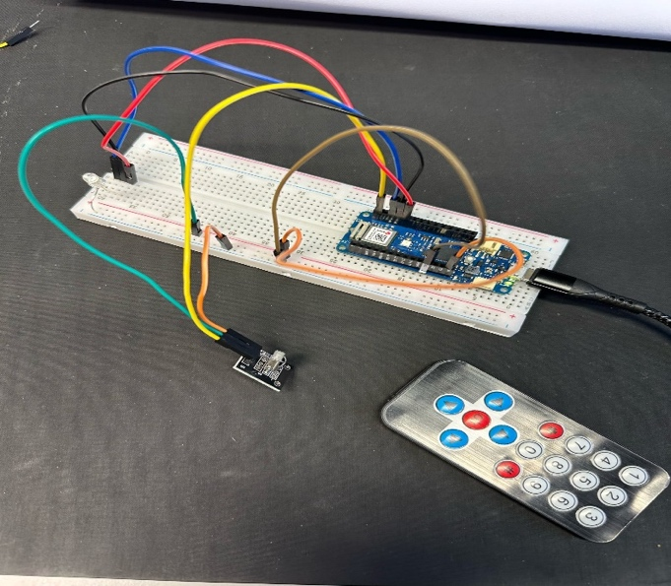  Components used: Arduino MKR WiFi 1010, IR remote and receiver, LED, breadboard, wire connectors | Code / Flowchart  _______________________________________________________________________________________________________________________________________________________________________________________________________________________________________________________________________________________________________________________________________________________________________________________________________________________________________________________________________________________________________________________________________________________________________________________________________________________________________________________________________________________________________________________
Results / Observations  ______________________________________________________________________________________________________________________________________________________________________________________________________________________________________________________________________________________________________________________________________________________________________________________________________________________________________________________________________________________________________________________________________________________________________________________________________________________________________________________________ | Reflection / Code Function  ____________________________________________________________________________________________________________________________________________________________________________________________________________________________________________________________________________________________________________________________________________________________________________________________________________________________________________________________________________________________________________  Challenge: Assign at least three buttons to three different device behaviours.  Real-world link: Local human control of a smart device.

Task 10: WiFi Connection and Signal Strength (RSSI)
Aim: Connect the board to WiFi and observe signal strength.
Circuit / Build Evidence  Insert circuit screenshot / lab photo here  Components used: Arduino MKR WiFi 1010, approved WiFi network, USB cable, Serial Monitor | Code / Flowchart  ______________________________________________________________________________________________________________________________________________________________________________________________________________________________________________________________________________________________________________________________________________________________________________________________________________________________________________________________________________________________________________________________________________________________________________________________________________________________________________________________________________
Results / Observations  _______________________________________________________________________________  _______________________________________________________________________________  _______________________________________________________________________________  _______________________________________________________________________________  _______________________________________________________________________________  _______________________________________________________________________________  _______________________________________________________________________________ | Reflection / Code Function  _________________________________________________________________________________________________________________________  _________________________________________________________________________________________________________________________  _________________________________________________________________________________________________________________________  ___________________________________________________________________________________________________________________________Challenge: Record RSSI at three distances from the access point and explain the pattern.  Real-world link: Connectivity planning for IoT deployments.

Task 11: DHT22 Cloud Dashboard and Data Visualisation
Aim: Publish temperature and humidity data and visualise it as a time series.
Circuit / Build Evidence  Insert circuit screenshot / lab photo here  Components used: Arduino MKR WiFi 1010, DHT22 sensor, cloud dashboard, breadboard, wire connectors | Code / Flowchart  ___________________________________________________________________________________________________________________________________________________________________________________________________________________________________________________________________________________________________________________________________________________________________________________________________________________________________________________________________________________________________________________________________________________________________________________________________________________________________________________________________________________________________________________________________________________________________________________________________________________________________________________________________
Results / Observations  ________________________________________________________________________________________________________________________________________________________________________________________________________________________________________________________________________________________________________________________________________________________________________________________________________________________________________________________________________________________________________________________________________________________________________________________________________________________ | Reflection / Code Function  _____________________________________________________________________________________________________________________________________________________________________________________________________________________________________________________________________________________________________________________________________________________________________________________________________  Challenge: Set an alert or visual marker for an abnormal reading.  Real-world link: Remote environmental monitoring and analytics.

Task 12: Multi-Sensor Monitor (self-test)
Aim: Integrate multiple sensors and create clear normal/warning conditions.
Circuit / Build Evidence  Insert circuit screenshot / lab photo here  Components used: Arduino MKR WiFi 1010, DHT22, LDR, gas/air-quality sensor, OLED, buzzer or RGB LED | Code / Flowchart  ___________________________________________________________________________________________________________________________________________________________________________________________________________________________________________________________________________________________________________________________________________________________________________________________________________________________________________________________________________________________________________________________________________________________________________________________________________________________________________________________________________________________________________
Results / Observations  _______________________________________________________________________________________________________________________________________________________________________________________________________________________________________________________________________________________________________________________________________________________________________________________________________________________________________________________________________________________________________________________________________________________________________________________________________________________ | Reflection / Code Function  ____________________________________________________________________________________________________________________  _______________________________________________________________________________________________________________________________________________________________________________________________________________________________________________________________________________________________  Challenge: Design one rule that uses two sensor values together rather than treating them independently.  Real-world link: Smart buildings, comfort, and safety monitoring.

Additional Practical Activities
Two further short builds that continue the physical MKR WiFi 1010 lab series (Tasks 1–12 above) and consolidate input–process–output thinking. Both reuse components you already have and are designed to be quick wins before the innovation project.

Task 13: Push-Button Counter with OLED Display
Aim: Read a digital input from a push button and show a running count on the OLED screen.
Circuit / Build Evidence  Insert circuit screenshot / lab photo here  Components used: Arduino MKR WiFi 1010, push button, 10 kΩ resistor (or the internal pull-up), OLED SH1106G display (from Task 5), breadboard, jumper wires. | Code / Flowchart  ___________________________________________________________________________________________________________________________  _________________________________________________________________________________________________________________________________________________________________________________________________________________________________________________________________________________________________________________________________________________________________________________________________________________________________________________________________________________________
Results / Observations  _______________________________________________________________________________________________________________________________________________________________________________________________________________________________________________________________________________________________________________________________________________________________________________________________________________________________________________________________________________________________________________________________________________________________________________________________________________________________________________________________________________________________________________________________________________________________________________________________________________________________________________________________________________________________________________________________________ | Reflection / Code Function  ________________________________________________________________________________________________________________________________________________________________________________________________________________________________________________________________________________________________________________________________________________________________________________________________________________________________________________________________________________________________________________________________________  Challenge: Add simple debouncing so one press counts once, and a second button (or a long press) that resets the count to zero.  Real-world link: People counters at doorways, production-line tally counters and click-to-confirm controls.  AIoT extension (optional): Timestamp each press and, later, classify presses as “fast” or “slow” – a first step towards learning patterns from event data.

Task 14: RGB Mood Light with Smooth Colour Fading (PWM)
Aim: Use PWM (analogWrite) to mix red, green and blue smoothly and fade between colours.
Circuit / Build Evidence  Insert circuit screenshot / lab photo here  Components used: Arduino MKR WiFi 1010, common-cathode RGB LED, three 220 Ω resistors, breadboard, jumper wires. | Code / Flowchart  ________________________________________________________________________________________________________________________________________________________________________________________________________________________________________________________________________________________________________________________________________________________________________________________________________________________________________________________________________________________________________________________________________________________________________________________________________________________________________________________________________________________________________________
Results / Observations  _______________________________________________________________________________________________________________________________________________________________________________________________________________________________________________________________________________________________________________________________________________________________________________________________________________________________________________________________________________________________________________________________________________________________________________________________________________________________________________________________________________________________________________________________________________________________________________________________________________________________________________________________________________________________________________________________________________________ | Reflection / Code Function  __________________________________________________________________________________  __________________________________________________________________________________  __________________________________________________________________________________________________________________________________________________________________________________________________________________________________________________________________________________________________________________________________________________________________________________________________________  Challenge: Create a smooth “breathing” fade that cycles through several colours, and let the fade speed be changed in one place in your code.  Real-world link: Ambient status lights, notification indicators and smart-home mood lighting.  AIoT extension (optional): Drive the colour from a sensor reading (for example green = normal, red = warning) so the light communicates a live status at a glance.
Research Mini-Investigations
Use data from your own experiments to support your conclusions
Investigation A - Sensor calibration
Choose one analogue or environmental sensor. Record at least five readings across a useful range. Compare the readings with a reference, known condition or repeated measurement. Comment on variation and how you selected a threshold.
Test / condition | Reading / time | Observation

Conclusion: _______________________________________________________________________________________________

Task 15: Integrated IoT Innovation – Your Project
Aim: Design, build and evaluate a complete IoT solution to a real problem.
Circuit / Build Evidence  Insert circuit screenshot / lab photo here  Components used: At least one sensor, at least one output/actuator, Arduino MKR WiFi 1010, local display or cloud connection where appropriate | Code / Flowchart  ________________________________________________________________________________________________________________________________________________________________________________________________________________________________________________________________________________________________________________________________________________________________________________________________________________________________________________________________________________________________________________________________________________________________________________________________________________________________________________________________________________
Results / Observations  ______________________________________________________________________________________________________________________________________________________________________________________________________________________________________________________________________________________________________________________________________________________________________________________________________________________________________________________________________________________________________________________________________________________________________________________________________________________________________________________________________________________________________________________________________________________________________ | Reflection / Code Function  ________________________________________________________________________________________________________________________________________________________________________________________________________________________________________________________________________________________________________________________________________________________________________________________________________________________________________________________________________________________________________________________________________________________________________________________________________________________  Challenge: Include one measurable evaluation: accuracy, response time, range, reliability or energy use.  Real-world link: Your chosen application area.

Investigation - Local vs cloud response
Compare the response time of a local action (for example LED switching) with a cloud-triggered action. Repeat the test several times and comment on delay and variation.
Test / condition | Reading / time | Observation

Conclusion: _______________________________________________________________________________________________

Final IoT Innovation Challenge
Plan, build, test and explain a complete IoT solution
Project requirement
Your project should solve a clear problem and include a sensing/input element, processing/decision logic and an output, actuator, display or cloud action. Stronger projects will also include connectivity, data visualisation, security consideration or an AIoT/digital-twin extension.

Project title
Problem you are solving
Target user / context
Main sensor(s)
Output / actuator / display
Connectivity / cloud platform
Success measure

System architecture / data-flow diagram
Sensor → Device → Network/Logic → Output/Cloud/User

Final IoT Innovation Challenge - Evidence and Evaluation
Build evidence / photograph
Key code or flowchart
Results and measured evaluation
Problems encountered and how they were solved
Limitations and future improvements

Final Reflection and Submission Check
1. What are the three most important IoT skills you developed during this module?
____________________________________________________________________________________________________________________________________________________________________________________________________________________________________________________________________________________________________________________________________________________________________________________________________________________________________________________________________________________________________________________________________________________________________________________________________________________________________________________________________________________________________________________________________________________________________________________________________________________________________________________________________________________________________________________________

2. Which practical activity taught you the most, and why?
___________________________________________________________________________________________________________________________________________________________________________________________________________________________________________________________________________________________________________________________________________________________________________________________________________________________________________________________________________________________________________________________________________________________________________________________________________________________________________________________________________________________________________________________________________________________________________________________________________________________________________________________________________________________________________________________

3. Describe one technical problem you solved and what you learned from it.
___________________________________________________________________________________________________________________________________________________________________________________________________________________________________________________________________________________________________________________________________________________________________________________________________________________________________________________________________________________________________________________________________________________________________________________________________________________________________________________________________________________________________________________________________________________________________________________________________________________________________________________________________________________________________________________________

4. How has your understanding of security, privacy or responsible IoT changed?
__________________________________________________________________________________________________________________________________________________________________________________________________________________________________________________________________________________________________________________________________________________________________________________________________________________________________________________________________________________________________________________________________________________________________________________________________________________________________________________________________________________________________________________________________________________________________________________________________________________________________________________________________________________________________________________________

5. If you continued your final project for four more weeks, what would you improve?
_________________________________________________________________________________________________________________________________________________________________________________________________________________________________________________________________________________________________________________________________________________________________________________________________________________________________________________________________________________________________________________________________________________________________________________________________________________________________________________________________________________________________________________________________________________________________________________________________________________________________________________________________________________________________________________________

Submission checklist
☐ Research activities completed
☐ Tinkercad activities supported by evidence
☐ Physical lab activities supported by evidence
☐ Code or flowcharts included
☐ Results/observations recorded
☐ Challenges/extensions attempted where appropriate
☐ Final mini-project completed
☐ Final reflection completed

